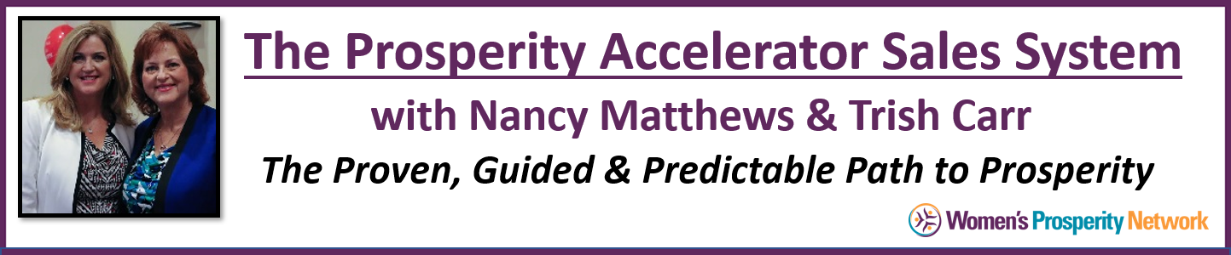



Discovery Call Client Conversion Formula
Low Cost or Complimentary Sessions

YOUR INTENTION: Discover what’s happening in your prospect’s life (and/or business) and how you may provide value for them.

Suggested time for Complimentary Discovery Calls is 30 to 45 minutes.
Keep a buffer of 15 minutes in your schedule to leave room for finalizing their enrollment.

- Have an initial intake form completed prior to the scheduled discovery call. Do your best to review it prior to the session. This serves two important purposes. First, it gets the prospect focused on what they do really want and second, it lets you gain insight into what they’re looking for (and some background on them too).
  - CLICK HERE for a Sample Intake Form
- Open the call with …
“I’m so looking forward to our time together today, thanks for taking a few minutes to fill out the form, I definitely have some ideas I want to share with you, but before we get started … do you have a burning question or something you know you’d most like to get from our time together today.”

What if they didn’t fill out the form you sent them?
“It doesn’t look like you had a chance to fill out the form I sent you --- that’s okay, we can easily move forward today as I’ve taken some time to look at your website (or social media or I remember quite a bit from our first conversation) so I know a little about what you’re up to and definitely have some ideas to share with you. But before we get started … do you have a burning question or something you know you’d most like to get from our time together today?

BAM!!!
This question is so powerful and sets you up for success in delivering a result on the call (but not giving away the farm) and sets you up to have them want even more from you.

What to expect when you ask the question … do you have a burning question or something you know you’d most like to get from our time together today?

Possibility 1 – Some people (especially those who have filled out the form) will be very clear and concise when you ask this question and quickly respond with …
“Well actually, yes, I’d really like to know _______”
(then they will fill in with a problem that relates to the area of expertise you are known to them for. Examples: How to build a funnel, how to not need a nap in the middle of the day, how to get more clients, what technology to use for ___)

Possibility 2 – Some will say, “I don’t know” at first …then they will come up with what they want. Just be mindful not to overstep on their sentence, “I don’t know” or “I’m not sure” as they may still be thinking about it. Silently count to 4 and if they don’t follow with what they want, go to
“That’s fine … I always like to check in on that first to be sure we’re getting to whatever matters to you most. May I ask you a couple of questions so we can dial in on the best way I can support you today?”

Return to Steps 1 and 2 of the Anatomy of the Sales Process (Being a GREAT Interviewer: Asking Questions to Uncover Problems) that you have tailored for the problems you solve.

Once you ask 2 to 3 questions, you’ll have a sense of what their main area of ‘pain’ or ‘problem’ is so that you can offer a tip or advice on that one area.

Remember that this will be conversational giving time for the person to answer your questions, provide you with additional information that narrows in on their situation and issues they want to solve or get relief from.

The goal is to accomplish this part of the conversation within 20 to 30 minutes. Then, transition to the invitation to learn more about working with you as follows:

“So, when we first started talking today you said you wanted to know (or learn) _____, did you find value in our time together today?”

--- They ALWAYS will say, ‘YES” often followed by, “Wow, that was really helpful.”

Then you continue with …
“I’m so glad we had this time together today and that you got good value from our call. As you can well imagine, the process of ________ (achieving their goal, getting lasting results, etc.) takes time and today we really just touched upon the tip of the iceberg. Would you like to know how we can continue working together so that you get exactly what you want?”
(be specific here, using the words they shared earlier in the call or on their intake form).

--- They ALWAYS will say, “YES … please do”

Here you will either get questions about some particulars of the program and how it will work for them.
And/or – here is where some objections may arise. Refer to Steps 9 and 11 for specific responses.

