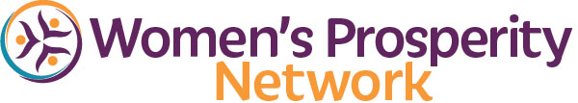


Let’s Dive In

- ___________________

- ___________________

- ___________________

- ________________

- ________________

- ________________

- _________________

- _________________

- _________________
Keep Yourself in Flow & Momentum

Clarity
1.
Clarity
2.

Clarity
3.
Confidence
1.

Confidence
2.
Confidence
3.

Capabilities
1.
Capabilities
2.

Capabilities
3.

ENROLLMENT NOW OPEN
We only open enrollment quarterly to ensure quality results, continuous progress
and meaningful connections for all Members.

2nd Quarter Session Begins March 21st
Enrollment Ends March 27th
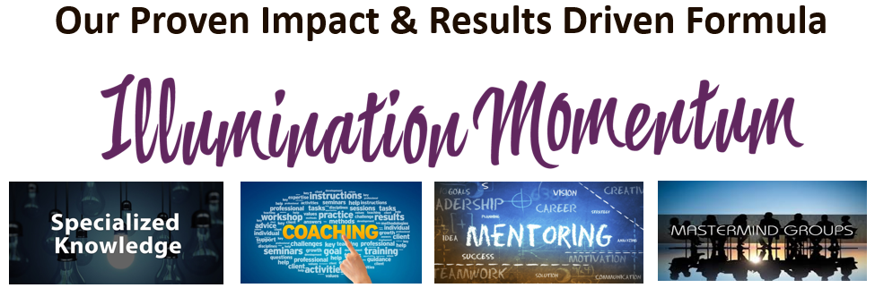
“Within 30 days of joining Momentum, I doubled my rates and had more clients. As a result of Momentum, I had my first 5-figure month, added 2 new team members and hit the highest income I’ve ever made.”
~ Terri Watkins
“We are all businesswomen…we belong to other groups and we still need THIS GROUP to support us in the spaces that build us personally. MOMENTUM is the name for a reason…the movement forward is everything.”
~ C. Simone Rivers, MBA

“I surpassed what I made last year (and that’s with 3 months of COVID thrown in! I was basically brick and mortar and moved my business online and made more in 2020 than I did in 2019. love Momentum Monday. I learn new ideas from everyone, not only from Nancy, the support and accountability is perfect for me.” ~ Sally DiCesare, RDH, BS

“The focus Momentum has on accountability is critical and missing from most programs I have participated in. Great program!!
~ Cheryl & Dr. Bob Levine

“I belong to other groups. I RUN other groups. I value WPN & Momentum for the resources, both time-saving and income producing.” ~ PeggyLee Hanson

“Momentum is incredible! =) Saved my business!
~ Regena Rosa Celeste

Enroll Today
WomensProsperityNetwork.com/Get-Momentum

