

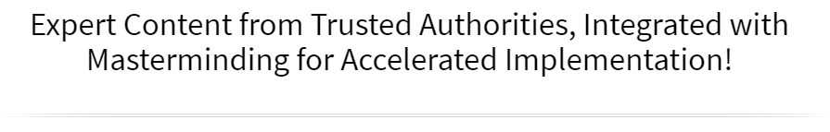



Online Workshop & Mastermind

Create Your Inspired Action Plan for 2022 & Beyond
Increase Your Reach, Your Impact & Your Income

June 17th & 18th
Via Zoom!

►
https://zoom.us/j/9604311277
Required Meeting Password: WPN
or Dial In: 1-929-205-6099, Meeting ID 960 431 1277

Schedule (Both Days)
Please Note: Times are approximate due to the interactive nature of this experience.

 | Eastern | Central | Mountain | Pacific
Start Time | 11:00am | 10:00am | 9:00am | 8:00am
Stretch Break | 12:15 to 12:30pm | 11:15 to 11:30am | 10:15 to 10:30am | 9:15 to 9:30am
Lunch Break | 1:30 to 2:00 pm | 12:30 to 1:00pm | 11:30am to 12pm | 10:30am to 11am
Stretch Break | 3:30 to 3:45pm | 2:30 to 2:45pm | 1:30 to 1:45pm | 12:30 to 12:45pm
Event Concludes | 5:00pm | 4:00pm | 3:00pm | 2:00pm

Welcome to The Legendary Level Up Mastermind Experience

You are about to take part in our proven prosperity system designed to bring you extraordinary results in every area of your life and business. Here are some suggestions to support you in getting the most from this experience:

- Dream Big: Give yourself permission to dream big and be open to the expected and unexpected ways that your dream and goals will be realized.

- Connect & Collaborate: Make an effort to not just meet one another, but to really connect so that you can discover ways to collaborate, support each other and serve your customers even better.

- Have Fun: One of the things we learned early on from our mother was that life (and business) can and should be fun! If you’re not having fun, get back to your heart’s desire and the reason you created your business.

What Members Are Saying:

“Becoming a Member of Women’s Prosperity Network was one of the best decisions I’ve made. Thanks to the way WPN Leadership brings us together and the business development strategies they provide, our business has increased ten times! The heart and spirit of this community is women supporting each other, doing business with each other, and making a positive difference in the world together.” ~ Gladys Diaz, HeartsDesireIntl.com

“The WPN community, ideology, the leaders and their vision have profound value for anyone wanting to enrich their lives.” ~ Jodi Darren, TV Spokesperson, Entrepreneur



Levelling Up in the “Certain” Way
Your Step-by-Step System for a Business You Love & That Loves You Back!

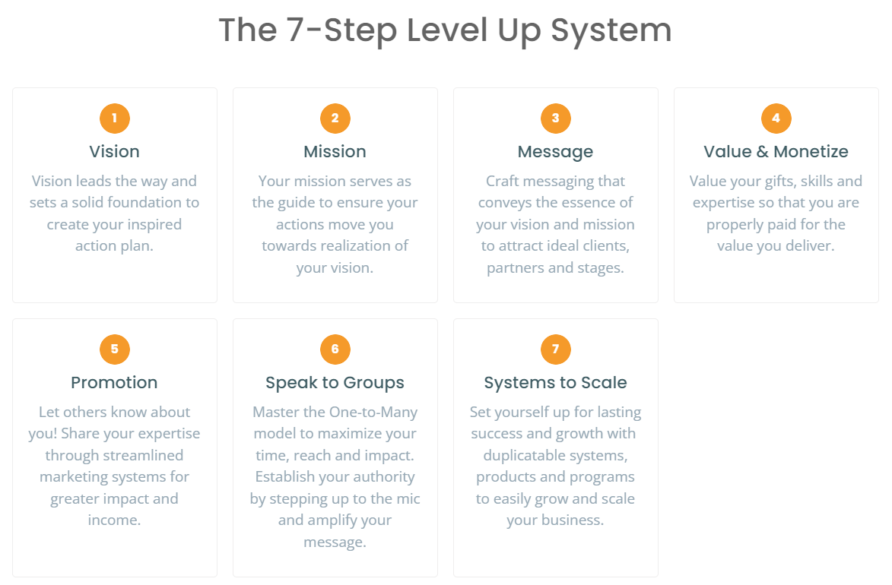
“Vision without action is merely a dream.
Action without vision just passes the time.
Vision with action can change the world.”

~ Joel A. Barker (Futurist, Author, Film Maker)

Steps 1 & 2
Vision & Mission
Your Vision for Impact | How You’ll Create It (Goals)

Definition of Vision Statement
My vision for the impact I want to make is:
(your big vision, not date specific)

Activity: It’s three (3) years from today and you are reflecting upon all the wonderful things that have happened in your life and how it has significantly improved in every area. Imagine your finances, relationships, career and health are all as you’ve always wanted them to be. Think about some of your achievements, celebrations, vacations, and exciting surprises that happened during these three (3) years.

Date: June 17, 2024

This Year What I Would LOVE to Experience…
Write down one thing (or more) that you would love to experience in the next year:

Finances | Relationships | Health & Fitness
Career | Fun & Play Time | Contribution & Legacy
Personal Growth | Spiritual Development | Hobbies

Now, let’s chunk it down to specific goals
The impact I want to have realized by December 31, 2022 is:
Example: Earn $50,000 by serving 50 or more clients
Example: Have my book published and read by 300 people
Example: 25 people have reduced their body fat and improved their overall health
Example: 1,000 women are engaged in my FB group, programs, products, and services
Example: Have delivered 25 presentations sharing my message for impact

I know I will have realized this goal when:
What is the very last step in the process of achieving this goal? What specifically will have to have happened for you to know you achieved this goal?
Example: When I look in my bank account and see $50,000 having been deposited through the year.

Steps 3
Messaging
Magnetic Messaging | Inspiring Others to Action

The Impact-Focused 30-Second Commercial
Who are your people and what do they want / need?

- Who are your people?

- What is the problem they have?

- What result do you get them?

Example: I show frustrated entrepreneurs how to get over their resistance to making making follow-up and sales calls so that they serve more people, earn more money and actually love doing it!
Example: I work with busy professionals, stressed entrepreneurs and moms juggling it all to be and to feel cool, calm and in control by giving them strategies and tools with 1-1 support, workshops and DIY audio and video tools.
Now, it’s your turn!

Steps 3
Messaging
Magnetic Messaging | Inspiring Others to Action

Quick Tip Formula
How to Grab Attention & Create Engagement in 2 Minutes

No more getting stumped on what to say on your FB Live and IGTV videos, this quick formula will do the trick and get people interested, engaged and inspired to connect with you to learn more about how you can help them.

“Be known before you’re needed.”
~Cheri Martin
Social Media Marketing Expert

- Introduce yourself and get to the point quickly by stating the problem / issue you’ll solve with your tip:

- Introduce
  - Hi, it’s Trish Carr from Women’s Prosperity Network (or I’m… not My name is)
- State the problem (here’s some options to choose from and be able to switch it up)
  - People often ask me…
  - or, a question that comes up is…
  - or, I got an email asking…
  - or, one of my clients recently ran into this issue…

- Give your problem/question context:

- This issue is important when you’re dealing with…, feeling…, having to… or especially now when…

- Give your solution:

  - So here’s an easy way to solve that..,, do that…, make that happen…

- Encourage people to connect with you (inspire them to action)

- You can find out more about this at…
  - Website with opt in for free gift,
  - Our FB group (or page) where we answer questions like these in even greater detail
  - An upcoming event you’re hosting
  - Just send me a message and we can set up a time to talk and see how tips like these will support you in having (result they want … i.e. more confidence in making sales calls)

Make it Easy for Them to Take Action in the Moment!
Be sure to add the link in the content written with the post
(FB Group/Page, Website Page)

- Invite them to give their thoughts/opinion:

  - To create even more engagement, finish with a specific question – and be sure that also goes at the END of the written post and the video.

    - Give me your opinion in the comments
      - How often do you deal with this?
      - Or, how do you handle when…?
      - Or, when was the last time you dealt with something like this?
      - Or, what do you do when…?
Example:

Hi, it’s Trish Carr with your weekly Influential Communication tip. Something I get asked often and something a client mentioned just yesterday is how do I remember my flow and remember to say what I want to say? And I’ve heard that over and over – it’s one of the greatest fears about speaking on stages and it’s especially important if you have nothing to prompt you like a PowerPoint or Keynote presentation. In a lot of speaking engagements, a PPT isn’t possible.
So how do you stay on track and remember what you want to say?
Besides the obvious Practice, Practice, Practice, a simple easy way is by giving your audience a handout so they follow along with you. A simple, one-page, fill-in the blanks type handout gives you permission to hold that same piece of paper in your hand – except your paper has all the answers and a brief note next to each point with a prompt reminding you what you wanted to be sure to mention.
For more on speaking with influence and to get the formula for influential presentations, go to SpeakingForFunandProfit.com.
I’d love to hear from you – how do you remember what to say when you’re on the stage or speaking to groups? Give me your thoughts in the comments below. Till next Tuesday – remember, It’s Just a Conversation.
Problem | Tip | Next Step

Step 4
Value & Monetize

“The single most important asset we have is our mind.
If trained well, it can create enormous wealth.”
~ Robert Kiyosaki

Special Guest, Gail Dixon
It’s Time to Name It, Frame It & Claim It™
Register Today at ► HeartsVoiceMovement.com/message

Special Guest, Jill Lublin
Get Your Free Publicity Action Guide
Go to ► PublicityCrashCourse.com/freegift

Welcome Back!
Day 2

My Intentions & Goals to Achieve by December 31, 2022
Business | Personal
Success formula … fuel your intentions and inspired actions by knowing the
emotional and intangible factors related to achieving your goals.
Motivation
WHY I want these goals?
(the specific outcomes you are looking for)
List ALL the Benefits here (of attaining your goals)
The BIG Benefit (of achieving goals)
What is the PAIN? (of NOT achieving your goals)
Achieving this Goal will also help me (other areas)
Obstacles or Challenges
What obstacles or challenges may I encounter?
Ways to get past the obstacle(s) or challenge(s)?
How will you or your business need to be different?
(a worthwhile goal often requires us to look at or do things differently)
In order to achieve these goals I/we will START doing
In order to achieve these goals I/we will STOP doing
In order to achieve these goals I/we will need to be someone that is
Moving Forward
Resources available to achieve these goals
Resources I will need to achieve these goals

Step 4
Value & Monetize
What You’ll Deliver (Products & Services) | How You’ll Reach People (Marketing)

Be Prepared to Serve and Receive!
Funnelology:
Creating Funnels for Maximum Impact & Income!

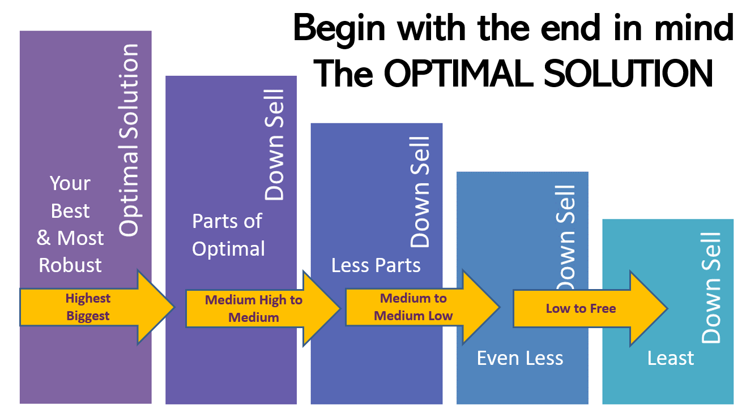

If your ideal client was sitting across from you (or on the phone/zoom), and they had the exact problem that you’re an expert at solving, what would your optimal solution be?

The optimal solution for my ideal client is:
Next, pull out pieces from the Optimal Solution to Create Smaller Offerings

High-End to Medium  $500 to $5,000 | Small to Medium  $50 to $500 | Free & Low Cost  $0 to $50

Miscellaneous Ideas & Notes:

Step 5
Promotion for Profits
What You’ll Deliver (Products & Services) | How You’ll Reach People (Marketing)

Driving people to you so that they can get their desired results
(and you make your desired impact).

Where do you find clients and how will you serve them when you meet them there?

Where | Solutions / Invitations / Offers | Price Points
Networking, Tradeshows, Conferences (Virtual & In-Person) | Free / Low Price  PDF’s, Quizzes  Short Videos, Audios  Mini-Course (Video or Audio)  Free / Low Cost Events (Webinars, Zooms) | $0 to $30
Online (Social Media, Website) | Free / Low Cost  Facebook Groups / Pages  PDF’s, Quizzes  Short Videos, Audios  Mini-Course (Video or Audio)  Free / Low Cost Events (Webinars, Zooms | $0 to $30
Speaking Engagements  (Includes Webinars) | Low to Middle Price  Your Signature Course  Specialized Program or Training  Live or Evergreen (already created) | $99 to $2000
Follow Up Connection Calls | Based upon need / match  Discovery call reveals their level of need / desire to get result | $0 to Highest
Referrals from Advocates | Based upon need / match  Discovery call reveals their level of need / desire to get result | $0 to Highest
Repeat Customers | Based upon need / match  Discovery call reveals their level of need / desire to get result | $0 to Highest

Step 6
Speaking to Groups
The One-to-Many Model

Special Guest, Mark Porteous
21 Ways to catapult Your Business Using Joint Ventures, Collaborations & Partnerships
Go to ► bit.ly/jvgift

Special Guest, Laura Barker, JD
Master Class & Training Workbook: The Unfair Advantage to Online Lead & Client Generation on LinkedIn
Go to ► BarkerBusinessSolutions.com/masterclass
Step 7
Systems to Scale

Note: An INSPIRED action plan is rooted in doing things in “The Certain Way”

- Actions feel good
- Every action is backed by faith and purpose
- We are open to new opportunities and avenues for the realization of our desired vision and resulting impact for ourselves and others

Doing things in “The Certain Way”

- Ongoing connection to your bigger purpose and impact
- Being an “advancing personality” (i.e. Being The One)
- When fear, doubt or uncertainty arise, seek support and mentoring
- When you notice thoughts of “Well, I couldn’t possibly do that” or “It won’t work” … IMMEDIATELY ask … “What if I could?”

Become the Master of Your Time – Business Time Mastery Formula

% | Hours | Activity
 |  | Sales Conversations, Presentations & Follow Ups
 |  | Marketing (email, social media, ads, flyers, networking)
 |  | Content Creation, Copywriting, Administrative
 |  | Client Fulfillment
 |  | Planning, Learning, Mentoring

Become the Master of Your Energy – Pay Attention to ALL OF YOU

Personal Development & Mindset | Physical Environment & Self-Care
Intentions:  - Read / Listen Book  - Journal  - Attend Event  - Other | Intentions:  - Sleep  - Exercise  - De-Clutter  - Other
Business Goals | Spiritual Connection & High Vibration
Intentions:  - 3 Action Items Towards My Goals  - Income Generated  - Feel inspired and grateful about my work | Intentions:  - Gratitude  - Impress Upon / Connect with Infinite Substance  - Meditate

Self-Awareness – Where Do You Get Stuck, Stopped or Stalled?
Focus Forward Inspired Action Plan

Pick Up Speed & Clarity - Planning & Marketing from Your Funnel
What is your revenue goal to achieve from July 1st through December 31, 2022?

Next, break it down:
What | Price | How Many | Total
Optimal Solution
Down Sell #1
Down Sell #2
Down Sell #3
Next Plan It Out
Total 3rd Quarter | July | August | September
Revenue Goal $___________

# of Speaking Gigs ________

Courses, Promotions or Programs Offering
(This will drive your marketing content.)
Total 4th Quarter | October | November | December
Revenue Goal $___________

# of Speaking Gigs ________

Courses, Promotions or Programs Offering
(This will drive your marketing content.)

