

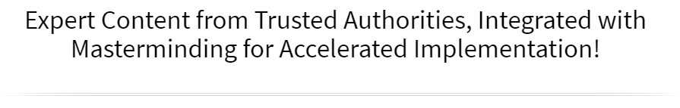

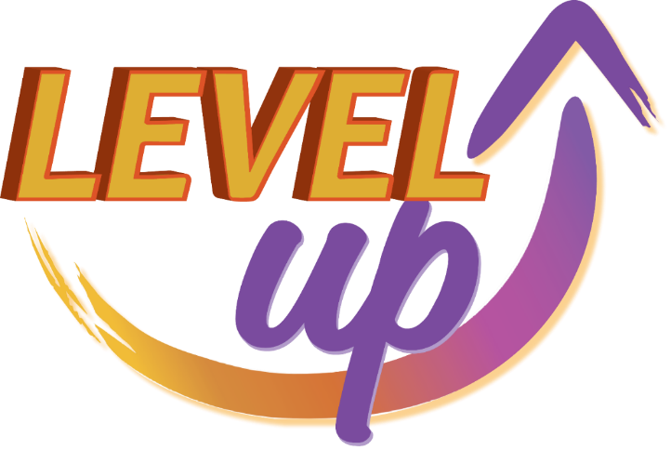

Online Workshop & Mastermind

Create Your Inspired Action Plan
Increase Your Reach, Your Impact & Your Income

June 16th & 17th
Via Zoom!

►
https://zoom.us/j/9604311277
Required Meeting Password: WPN
or Dial In: 1-929-205-6099, Meeting ID 960 431 1277

Schedule (Both Days)
Please Note: Times are approximate due to the interactive nature of this experience.

 | Eastern | Central | Mountain | Pacific
Start Time | 11:00am | 10:00am | 9:00am | 8:00am
Stretch Break | 12:30 to 1245 pm | 11:15 to 11:30am | 10:15 to 10:30am | 9:15 to 9:30am
Stretch Break | 2:15 to 2:30 pm | 12:30 to 1:00pm | 11:30am to 12pm | 10:30am to 11am
Stretch Break | 3:30 to 3:45pm | 2:30 to 2:45pm | 1:30 to 1:45pm | 12:30 to 12:45pm
Event Concludes | 5:00pm | 4:00pm | 3:00pm | 2:00pm

Welcome to The Legendary Level Up Mastermind Experience

You are about to take part in our proven prosperity system designed to bring you extraordinary results in every area of your life and business. Here are some suggestions to support you in getting the most from this experience:

- Dream Big: Give yourself permission to dream big and be open to the expected and unexpected ways that your dream and goals will be realized.

- Connect & Collaborate: Make an effort to not just meet one another, but to really connect so that you can discover ways to collaborate, support each other and serve your customers even better.

- Have Fun: One of the things we learned early on from our mother was that life (and business) can and should be fun! If you’re not having fun, get back to your heart’s desire and the reason you created your business.

What Members Are Saying:

“Becoming a Member of Women’s Prosperity Network was one of the best decisions I’ve made. Thanks to the way WPN Leadership brings us together and the business development strategies they provide, our business has increased ten times! The heart and spirit of this community is women supporting each other, doing business with each other, and making a positive difference in the world together.” ~ Gladys Diaz, HeartsDesireIntl.com

“The WPN community, ideology, the leaders and their vision have profound value for anyone wanting to enrich their lives.” ~ Jodi Darren, TV Spokesperson, Entrepreneur

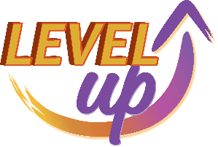

Levelling Up in the “Certain” Way
Your Step-by-Step System for a Business You Love & That Loves You Back!

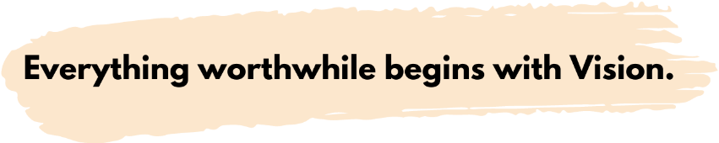 | “Vision without action is merely a dream. Action without vision just passes the time. Vision with action can change the world.” – Joel A. Barker (Futurist, Author, Film Maker)

Visualization Activity
How old is the future you?
What was the gift?
What color did you paint with?
What else did you observe?

Activity: It’s three (3) years from today and you are reflecting upon all the wonderful things that have happened in your life and how it has significantly improved in every area. Imagine your finances, relationships, career and health are all as you’ve always wanted them to be. Think about some of your achievements, celebrations, vacations, and exciting surprises that happened during these three (3) years.

Date: June 16, 2025

What I Would LOVE to Experience…
Write down one thing (or more) that you would love to experience in the next year:

Finances | Relationships |  | Health & Fitness
Career | Fun & Play Time |  | Contribution & Legacy
Personal Growth | Spiritual Development |  | Hobbies
Vision & Mission
Your Vision for Impact |  | How You’ll Create It (Goals)

Definition of Vision Statement
My vision for the impact I want to make is:
(Your big vision, not date specific)

How to Build a Tribe You Can Be Proud of and that Amplifies Your Impact

“A tribe is a group of people connected to one another, connected to a leader, and connected to an idea. For millions of years, human beings have been part of one tribe or another.
A group needs only two things to be a tribe – a shared interest and a way to communicate.”
~ Seth Godin, Author of Tribes: We Need You to Lead Us

Key Ingredients to Build Your Tribe & Create a Bonfire Effect in Your Business

What is your shared interest?
What is your common cause? (What is the system, structure, or socialization factors that cause the challenge to exist?)
What is your RALLY CRY? (The message that inspires others to want to be part of your tribe?)


Special Guest
Kathryn Yarborough

Find out if you’re authentically vibrant. Get Kathryn’s FREE Authentically Vibrant Assessment at: ManifestingClientsAcademy.com/HowVibrantAmI/

Want to get comfortable doing Facebook LIVES? Do Kathryn’s Fun Facebook LIVE Challenge, July 10-21st | Only $47. Find out more at ManifestingClientsAcademy.com/fun/

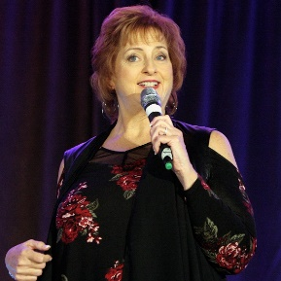
Trish Carr

Speaking for Fun & Profit

Tips & Insights from Women Just Like You!
  Dr. Heather Tucker | 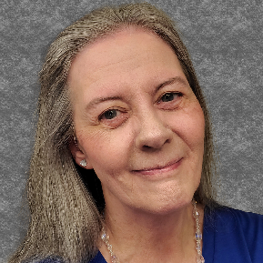  PeggyLee Hanson | 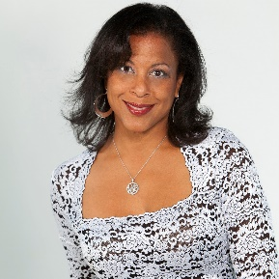  Karina Felix

How to Build a Tribe You Can Be Proud of and that Amplifies Your Impact
“A tribe is a group of people connected to one another, connected to a leader, and connected to an idea. For millions of years, human beings have been part of one tribe or another.
A group needs only two things to be a tribe – a shared interest and a way to communicate.”
~ Seth Godin, Author of Tribes: We Need You to Lead Us

3 Key Components to Grow Your Tribe - Communication

1.
2.
3.
Strategies to Keep Your Community Lit Up & Engaged

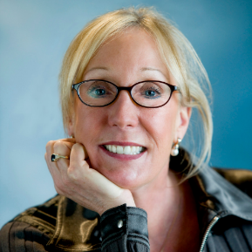
Special Guest
Janet Fish

Using ChatGPT with Email Marketing
How to Maximize Your Email List Using Artificial Intelligence
Register at ► BreakawayBusinessCoaching.com/emailwebreg

Welcome to Day 2 – Level Up!

Your Vision Statement / Rally Cry

My Intentions & Goals to Achieve by December 31, 2023
Business | Personal
Success formula … fuel your intentions and inspired actions by knowing the
emotional and intangible factors related to achieving your goals.
Motivation
WHY I want these goals?
(the specific outcomes you are looking for)
List ALL the Benefits here (of attaining your goals)
The BIG Benefit (of achieving goals)
What is the PAIN? (of NOT achieving your goals)
Achieving this Goal will also help me (other areas)
Obstacles or Challenges
What obstacles or challenges may I encounter?
Ways to get past the obstacle(s) or challenge(s)?
How will you or your business need to be different?
(a worthwhile goal often requires us to look at or do things differently)
In order to achieve these goals I/we will START doing
In order to achieve these goals I/we will STOP doing
In order to achieve these goals I/we will need to be someone that is
Moving Forward
Resources available to achieve these goals
Resources I will need to achieve these goals

Now, let’s chunk it down to specific goals.
The impact I want to have realized by December 31, 2023, is:
Example: Earn $50,000 by serving 50 or more clients
Example: Have my book published and read by 300 people
Example: 25 people have reduced their body fat and improved their overall health
Example: 1,000 women are engaged in my FB group, programs, products, and services
Example: Have delivered 25 presentations sharing my message for impact

I know I will have realized this goal when:
What is the very last step in the process of achieving this goal? What specifically will have to have happened for you to know you achieved this goal?
Example: When I look in my bank account and see $50,000 having been deposited through the year.

The Cash Flow Quadrant

E | B
S | I


Special Guest
Barbara Johnson

Level Up Your Profits with Barbara’s PROFIT FIRST MASTERCLASS
Special Pricing for WPN – Only $27 (normally $47)
Register at: tinyurl.com/profitfirstmc

Deliver Value & Monetize
What You’ll Deliver (Products & Services) | How You’ll Reach People (Marketing)

Be Prepared to Serve and Receive!
Funnelology:
Creating Funnels for Maximum Impact & Income!

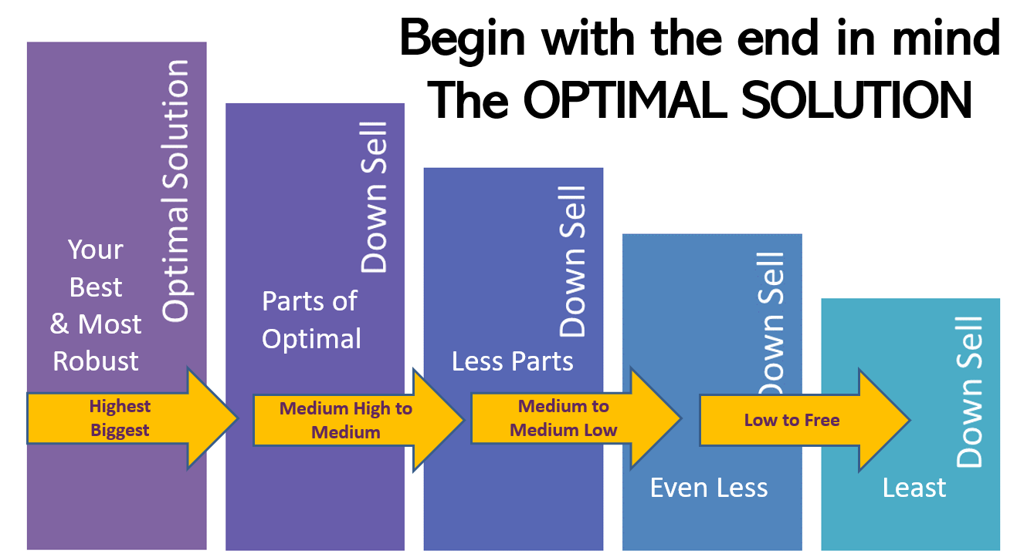

If your ideal client was sitting across from you (or on the phone/zoom), and they had the exact problem that you’re an expert at solving, what would your optimal solution be?

The optimal solution for my ideal client is:
Next, pull out pieces from the Optimal Solution to Create Smaller Offerings

High-End to Medium  $500 to $5,000 | Small to Medium  $50 to $500 | Free & Low Cost  $0 to $50

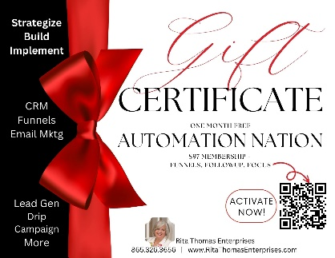

Special Guest
Rita Thomas

Gift Certificate for One Month FREE
In Automation Nation!
$97 Membership
Funnels, Follow Up & Focus
Claim Your Certificate at ► tinyurl.com/giftcert1mo

Top 21 Conversation Marketing Strategies
Put a ✓ next to the ones you are already consistently doing (i.e. on a monthly or weekly basis)

Speaking | Social Media | Website Related
Speaking to Groups  (In person & online) | Your Own Facebook or LinkedIn Group | Lead Capture  Opt In
Clubhouse  (Hosting and/or participating) | Contribute to Other LinkedIn or Facebook Groups | Nurture (Follow Up)  Sequences / Processes
Hosting Your Own Events  (In person & online) | Facebook Live Videos  (Quick Tips / Connections) | Blog on Your Site
Podcasting  (OPS – Other People Shows) | Facebook Stories / Reels | Write for Others  Blogs, Articles, Magazines
Podcasting  (Your Own Show) | Instagram Stories / Reels | Digital Products  (audios, eBooks, courses)
YouTube Videos  (long and/or shorts) | Tik Tok | Email Your List  (Monthly or More)
Get in the Press  Media Interviews | Twitter | Text Marketing

List the results you’re getting from the ✓ strategies:
- Growing your list (by how much) ______________________________
- New clients (how many, how often) ____________________________
- Strategic Alliances & Joint Venture Partners _____________________
- Resources for yourself or your business _______________________

After measuring and assessing the effectiveness of your current strategies, create your course for the remainder of the year. Which do you want to stop, start and/or continue?

Continue | Start | Stop

Activities to Drive Results – The 2x2 System

INSTRUCTIONS: Let’s keep it simple so that you’re consistently doing 2 simple things to get booked, post content and cultivate client relationships. The top chart is an example to follow – AND Select the Days of the Week that work best for YOU!
 | Monday | Tuesday | Wednesday | Thursday | Friday
Contacts |  | Reach out to 2 new contacts for speaking, podcasts, JV’s |  |  | Follow up with 2 contacts for speaking podcasts, JV’s
Content | Post content in 2 places |  | Post content in 2 places |  | Plan next week’s content
Clients |  | 2 connection conversations |  | 2 connection conversations
Tips & Insights from Women Just Like You!

  Dr. Patricia Rogers | 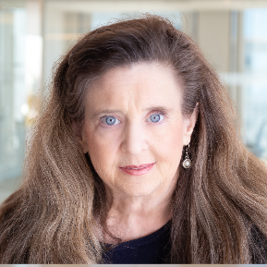  Laura Barker, JD

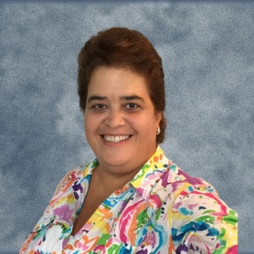  Jane Parmel | 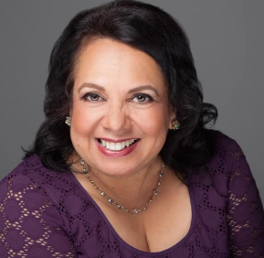  Raksha Joshi

Your Inspired Action Plan
“Miracles are all around us just waiting for US to have the vision to see them.” ~ Nancy Matthews

Note: An INSPIRED action plan is rooted in doing things in “The Certain Way”

- Actions feel good.
- Every action is backed by faith and purpose.
- We are open to new opportunities and avenues for the realization of our desired vision and resulting impact for ourselves and others.

Doing things in “The Certain Way”

- Ongoing connection to your bigger purpose and impact
- Being an “advancing personality” (i.e. Being The One)
- When fear, doubt or uncertainty arise, seek support and mentoring.
- When you notice thoughts of “Well, I couldn’t possibly do that” or “It won’t work” … IMMEDIATELY ask … “What if I could?”

Become the Master of Your Energy – Pay Attention to ALL OF YOU

Personal Development & Mindset | Physical Environment & Self-Care
Intentions:  - Read / Listen Book  - Journal  - Attend Event  - Other | Intentions:  - Sleep  - Exercise  - De-Clutter  - Other
Business Goals | Spiritual Connection & High Vibration
Intentions:  - 3 Action Items Towards My Goals  - Income Generated  - Feel inspired and grateful about my work | Intentions:  - Gratitude  - Impress Upon / Connect with Infinite Substance  - Meditate

My Desired Goal / Outcome by December 31, 2023, is:
Focus Forward Action Plan

Total 3rd Quarter | July | August | September
List Any Courses, Promotions or Programs You Are Launching Here
(This will drive your marketing content.)

Total 4th Quarter | October | November | December
List Any Courses, Promotions or Programs You Are Launching Here
(This will drive your marketing content.)

