

Making It Real, Making It Right,
Making A Difference & Making Lots of Money!

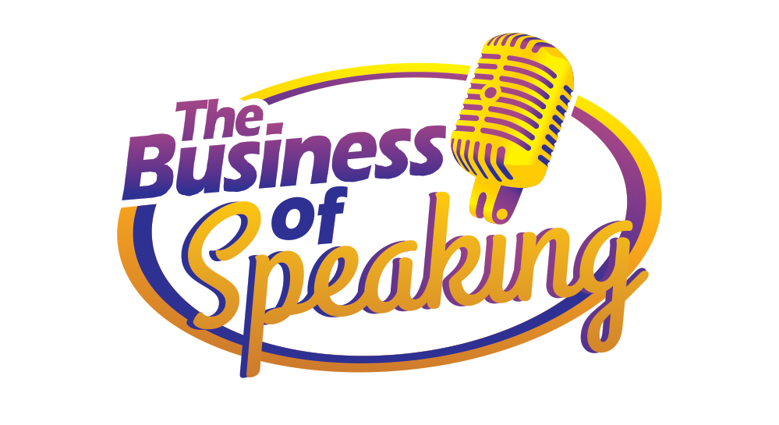
Expand Your Reach
Maximize Your Impact
Increase Your Revenue

Online Training

►
https://zoom.us/j/9604311277
Required Meeting Password: WPN
or Dial In: 1-929-205-6099, Meeting ID 960 431 1277

Welcome to Your Business of Speaking Workshop!

You are about to take part in newly innovated online Speaker Training workshop. Designed to give you the essential pieces needed today to take your message to the masses. Here you will learn the secrets of influence and persuasion in an authentic, non-salesy way. Here are some suggestions to support you in getting the most from this experience and in achieving your goals:

- Connect & Collaborate: Make an effort to not just meet one another, but to really connect so that you can discover ways to collaborate, support each other and serve your customers even better.

- Have Fun: One of the things we learned early on from our mother was that life (and business) can and should be fun! If you’re not having fun, get back to your heart’s desire and the reason you created your business.



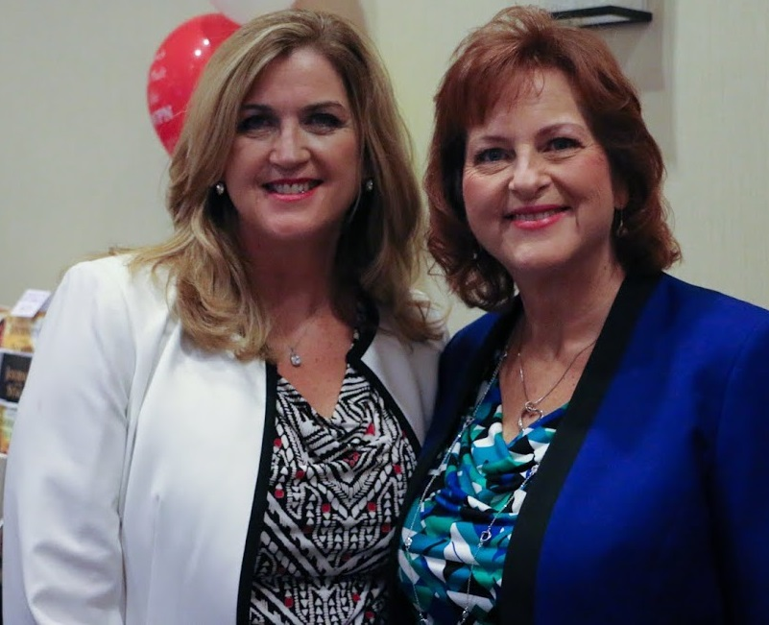 | 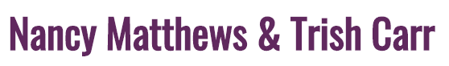  As Seen On/In:    Proud Members of and Partners with:

Here’s the Buzz:
This training gives you the formula for speaking live. They actually get you to stand in front of the room and do your presentation. This is what sets this WPN workshop apart from all the rest. I love it!
Linda Allred ~ The Hottest Ticket in Town

“I closed over $1,000 in sales AT the Boot Camp and the following week I was at a conference as an attendee and was able to use what I learned at the training to use in 1 on 1 sales conversations. The result … I closed $10,000 in sales – as an attendee!. If you want to have more influence and make more money, this training is priceless!” Gladys Diaz ~ Hearts Desire Int'l

I had been giving presentations for years and then hired Nancy as my coach. She not only helped me get my presentation perfect, I ended up with 5 clients that day – that is $2,500! This is phenomenal because there were only 20 people in the group! If you want better results from your presentations, call Nancy as fast as you can, she’s fantastic! Jeanne Vandermeer ~ Handwriting Analyst

Why Speak to Groups? | *HOT*
Ideas for places to speak:

What you need to grab their attention:  Clarity, Confidence & Communication Skills | *HOT*
PRESENTATION PROFITZER™ PLANNING WORKSHEET

YOUR INTENTION:

- What I want the listener to learn is _______________________________________________

- What I want the listener to be able to do after getting this information is:
______________________________________________________________________________________________________________________________________________________

YOUR AUDIENCE:

- Who is your audience? Who is this for? Consider:
  - What are they experiencing now?
  - What is important to them?
  - What are their problems, challenges and/or desires?
  - What do they want that I can give them?
  - What questions will they have?
  - Who is in the audience, i.e., am I dealing with a mix of styles, i.e., all engineers or party planners? What do I need to do to speak to everyone?
______________________________________________________________________________________________________________________________________________________
______________________________________________________________________________________________________________________________________________________

YOUR RESULTS:

- What do I want the audience to do?
- Buy a product or service?
  - How many, which ones, what price?
  - Understand my product/service better
  - Want more information
  - Be convinced, have a new perspective
  - Recommend me to others, create introductions and strategic alliances
______________________________________________________________________________________________________________________________________________________
___________________________________________________________________________

- How will I capture the sales and requests (order form, support person helping?)
- What is my follow-up structure?
____________________________________________________________________________________________________________________________________________________________
______________________________________________________________________________

PREPARATION WORKSHEET

1) Tell them what you’re going to tell them:
- Engage Your Audience
  - Grabber Statement
  - Startling Statistic
  - 2 “Yes” Questions
- Give a Roadmap of your Presentation – what can they expect, in what order?
- Share the WII-FM – Why is this important to them?
- Acknowledge your Audience - “MMFI-AM” – describe who they are, what they’re experiencing and possibly different knowledge levels on the subject.
- Let them know that you’re going to invite them to (choose from the following):
  - Work together so they can receive even more benefit
  - Have the opportunity for a special discount, bonus or package to take this further
  - Contact you for more information or consultation

2) Tell them:
Create your talk using the information you gathered in “Planning”
- Structure your flow and the body of your talk. Bring each point to life with a story, testimonial and/or for instance and back it up with supporting data and quotes:
  - Point #1_______________________________________________________________
    - Story, example, testimonial, data, quotes _______________________________
  - Point #2_______________________________________________________________
    - Story, example, testimonial, data, quotes _______________________________
  - Point #3_______________________________________________________________
    - Story, example, testimonial, data, quotes _______________________________

- Focus on Benefits and Feelings – stories and testimonials powerfully illustrate the problem and the solutions. Your stories are meant to evoke emotions.
- Supporting Data, Quotes: ____________________________________________________

3) Tell them what you told them:
Create a Powerful Close and Call to Action:
- Recap what you stated in the introduction, “By now…”
- Restate the WII-FM & Focus on Benefits
- Invite them to continue working with you – share your full price before discount
- Remind them of your testimonials, “If all this did…”
- Share the special event pricing and Ask for the Sale
- Affirm Their Good Decision - MMFI-AM
Other:
- Technology needed? (online access, projector/screen, computer speakers, phone, etc.)
- Visuals needed? (PPT, handouts, easel pages, etc.)
- Room layout, line of sight, time keeping
- Stage layout, i.e., table for your notes, your products, etc.
- Seating arrangement for group activities
- See Checklist for Speaking/Event Location Preparation

Timing of Your Presentations & Suggested Price Points

Total Speaking Time Allotted | 30 | 45 | 60 | 90
Opening  Grabber Statement/Question, WIIFM  Little bit of your credibility | 5 | 5 | 5 | 5
Body / Content  (Divide total time between points)  Point #1  Point #2  Point #3 | 18 | 28 | 38 | 65
Recap  Anchor back to opening and WIIFM | 2 | 2 | 5 | 5
Conclusion / Closing  Invitation to Next Steps | 5 | 10 | 12 | 15
Suggest Price Point for Offer | $20 to  $100 | $50 to  $200 | $100 to  $400 | $200 to  $1500

When considering what price point to offer, keep in mind these factors:
- As a beginning speaker where you are speaking to a cold audience (i.e. they are not at all familiar with you or your products and services), you will want to stay on the lower side of the spectrum.
- If you are speaking at an event where the host has great credibility and authority with the audience, you will be leveraging their credibility and can then move towards the higher price range.
- As you build your brand, reputation, and credibility, you will be able to leverage those assets to sell at the higher end of the spectrum.

LET’S PRACTICE YOUR ENGAGING OPENING

Prepare your opening as outlined in the training. Do not go into your content. Follow the outline below.
This is your opportunity to practice and get the gift of feedback to make it even better.

THE GOAL: Create powerful opening that:
- Acknowledges the promoter and the audience (MMFI-AM)
- Quickly grabs attention (2 “yes” questions; or quote; or statistic)
- Shows participants what’s in it for them to listen (WII-FM)
- Briefly outlines what you’re going to share
- Advises that you will share how they can take what they’ve heard/learned today and take it to the next level.

Example | Your Opening
1. Acknowledge the audience and promoter:
Thank you to the Health Association for inviting me here today. Let’s give them a round of applause for putting together this extraordinary event.
And I want to acknowledge you – for taking the time out of your busy schedules to be here. You obviously care about you and your family’s good health and are willing to do what it takes to have it. So give yourselves a round of applause!

2. Quickly grab attention:
And since that’s the case, raise your hand if you want to consistently prepare and eat healthy, nutritious meals?
And keep them up if you want it to be easy and affordable?

3. Show the audience what’s in it for them AND briefly outline what you’re going to share:
Great, that’s exactly what we’re going to talk about today. I’m going to show you 3 ways to easily incorporate healthy eating in your lifestyle so that you and your family get the powerful benefits food gives you.

4. Advise that you’ll give them an opportunity to take what you’re sharing to the next level:
And because you are people who know that maximizing your health is vital for you and your family, I’ll share an easy and affordable way for you to take what you learn today and immediately put it into practice at home.

FILL-IN-THE BLANK SAMPLE

3 DEADLY PRESENTATION
BLUNDERS TO AVOID

“To add value to others, one must first _________ _________.”
~John Maxwell
“Everyone Communicates, Few Connect”
DEADLY BLUNDER #1

1. __________ ________________________ with your audience.

You must change your focus:
- From __________________ to ___________________.
- From __________________ to ___________________.

DEADLY BLUNDER #2

2. _______________________ _____________ Powerpoint.

- Visuals are meant to __________________ the presentation.
- Use them _____________________________.

DEADLY BLUNDER #3

“Be sincere, be brief, be seated.”
~Franklin D. Roosevelt

- Simply being _______________________.

- Use ___________________ to bring your points to life.
- Keep your ________________ ______________________ upbeat.
- Use a variety of ________________ _________________.
Go to► WomensProsperityNetwork.com/yes-ready
Or Text Susan at 954-290-2240

SESSION NOTES & Ah-Ha’s
Session Notes & Ah-Ha’s | *HOT*

CALL TO ACTION

By now, you can see that broccoli is a nutritional miracle that supports you in living a long life while you look and feel great right now. It lowers blood pressure, reduces cholesterol and prevents cancer.

And by now you know that by simply adding the powerful nutrition that broccoli gives us, you’re taking a powerful step in keeping you and your family feeling good, looking good and in optimum health.

And because you know that feeling great, looking great and being healthy starts with what we eat, I’m making it easy for you to take action now so that you get the results you want.

My invitation for you today is to grab your copy of “Easy Recipes for Brilliant Broccoli.” With this, your family, especially the kids, will be surprised to learn they’re eating vegetables. You’ll be the star of the show and you’ll make healthy food taste like a delicacy. On Amazon and in stores the book sells for $35.

And when you take action now, I always reward action-takers, I’m including as a bonus for you today, a $100 broccoli gift certificate so you can save money while keeping your family healthy.
The total value of this package is $135.

If all this did was give you the renewed energy that Mery now has to play with her kids on the weekends instead of being tired and stuck on the couch, wouldn’t it be worth it?

If all this did was get your legs moving again without pain like it did for Licia, wouldn’t it be worth it?

If all this did was give you the clarity and focus to increase your income by 150% like Gladys experienced, wouldn’t it be worth it?

You can have that stamina, that energy and that clarity when you make broccoli your go-to vegetable.

So today, the recipe book which sells for $35 on Amazon, PLUS the $100 broccoli certificate – today you get both for only $35. Yes, only $35 for the recipe book showing you over 100 ways to make broccoli so that you’ll have a wide variety of delicious options PLUS $100 worth of this FREE miracle vegetable – all only $35.

We have only 20 books today – so go ahead now and see Melissa at the Brilliant Broccoli table (wave to Melissa so they see her) and get your copy and your $100 FREE certificate.

(MMFI-AM) As people who stay aware & informed, you know the crucial role food plays in your health.
(Call to Action Again:) I urge you to make broccoli your delicious 3x a week treat so that you experience miraculous results!

See me and Melissa in the back now and get your recipe book and Free $100 gift certificate so you can get started making healthy, delicious, easy meals right now!

LET’S PRACTICE YOUR POWERFUL CLOSE & CALL TO ACTION

Prepare your close and make an offer as outlined in the training. This is your opportunity to practice and get the gift of feedback to make it even better.

THE GOAL: Create powerful call to action that:
- Recap what you stated in the introduction, “By now…”
- Restate the WII-FM & Focus on Benefits
- Invite them to continue working with you – explain your offer, give full retail price
- Remind them of your testimonials, “If all this did…”
- Share today’s price – reiterate benefits
- Affirm Their Good Decision - MMFI-AM

Example | Your Close
1. Recap what you stated in the introduction, “By now…” Restate the WII-FM & Focus on Benefits & Problems You Solve
By now you know that broccoli is a nutritional miracle that supports you in living a long life while you look and feel great right now. It lowers blood pressure, reduces cholesterol and prevents cancer.
2. Invite them to continue working with you–
Ask for the Sale
And because you know that feeling great, looking great and being healthy starts with what we eat, I’m making it easy for you to take action now and get the results you want. My invitation for you today is to grab your copy of “Easy Recipes for Brilliant Broccoli” (Hold up a copy of the book.) With this, your family, especially the kids, will be surprised to learn they’re eating vegetables. You’ll be the star of the show and you’ll make healthy food taste like a delicacy. On Amazon and in stores the book is $35. And when you take action now I’m including a bonus… (Your offer may have more components, be sure to describe and detail each so the benefits are clear, ie, I give you this so that…)
Give FULL RETAIL VALUE of package now.
3. Remind them of your testimonials, “If all this did…” (repeat with 3 total reminders of testimonials)
4. Share the Special Event Pricing
You can have that stamina, that energy and that clarity when you make broccoli your go-to vegetable. Today for you, it’s only $35. (add bonus again – optional) And when you take action now I’m including…
5. Affirm Their Good Decision - MMFI-AM
As aware & informed people, you know the crucial role food plays in your health. (Call to Action Again) I urge you to make broccoli your delicious 3x a week treat and see miraculous results! See me in the back now and get your recipe book and $100 coupon for FREE broccoli so you can make cooking a breeze and experience the benefits right away! See me in the back now to get started…

SESSION NOTES & Ah-Ha’s
Session Notes & Ah-Ha’s | *HOT*

SESSION NOTES & Ah-Ha’s
Session Notes & Ah-Ha’s | *HOT*

SESSION NOTES & Ah-Ha’s
Session Notes & Ah-Ha’s | *HOT*
Creating Topics & Titles | *HOT*

WAYS TO GET PAID SPEAKING GIGS

Google: call for speakers ______________
(fill in the blank with year, type of presentation, i.e., call for speaker’s motivation, call for speaker’s health, call for speakers 2022, call for speaker’s customer service, etc.)

Contact industry associations
Lawyers – accountants, healthcare, etc.
Google: Association of Associations for listing of Associations & directoryofassociations.com

Speakertunity.com
The Direct Connections and Training to Fill Up Your Speaking Calendar, Create Explosive Business Growth and Change More Lives!

Speakerhub.com
Free online profile for organizers to find you and premium service available for greater visibility and listings of upcoming opportunities.

Find A Podcast at Matchmaker.fm

Lanyrd.com
The social conference directory
Create your profile, search for events

Speaking Gigs and Platforms for hosts: https://eventraptor.com – free & paid

Consult at companies
According to Business Week magazine: $39.3B was spent in 2016 to paid outside consultants

To book outside consulting, start local. Chances are you have a connection to a company where you live. Here is a formula you can use:

- Identity a company where you can talk to a decision maker.
- Research that company and identify the problem you will solve.
- Offer to take the decision maker out for a coffee, dinner or grab 10 minutes of their time. A cold email rarely works. Face to face is what closes the deal.
- Present the problem that you can help solve. This presentation should include hard numbers, not your opinion. You want to show this company why they can’t afford to not hire you. They also want to make sure they get a return on their investment.
- Charge a rate that’s worth your time.
- Do a good job and get referrals.

Or – come in through the back door:
- Identify who you know that works at a company with employees.
- Offer to do a ‘lunch and learn’ to share valued information
- Inspire the employees to ask for more and talk to the owner/supervisor/boss about continuing with the company as an outside expert.



Checklist for Speaking / Event Location & Virtual Preparation

For events where you’re speaking on someone else’s stage:
- How much time to speak?
- Request that they place a break after you speak (at least 10 to 15 minutes) to give audience time take you up on your offer. (Even if it’s not an official ‘sale’ you’ll want to have some call to action for audience next steps.)
- Find out about their audience – gender, age, financial, career, hobbies and mindset – things that are top of mind to them.
- What are the problems/desires of your audience as it relates to your solutions.
- Are there any influencers in the room so that you include them in your talk?
- What are the terms of agreement?
  - Are you being paid a fee for presenting?
  - Does it include purchase of a book or other product for each attendee (or instead of)
  - If you are selling, coordinate your price in accordance with the audience’s familiarity with selling from stage.
  - If selling from stage – who collects the money?
  - If selling from stage and sharing in revenue, what’s the split?
  - If not selling, let them know that you’ll be offering a free gift (a lead magnet).
  - Written Speaker Agreement
  - Is there a recording? Do I get a copy? Confirm you own the rights to use it.

Find out logistics:
- Size and layout of of room (theatre style, classroom, rounds, etc., and will it be set up ready to go?)
- If virtual, which online platform is being used.
- Expected number of attendees.
- Is there audio/visual available, i.e., a screen/projector for a presentation, microphone, etc. If virtual, confirm the ability to share your screen.
- If virtual, will you see the audience, will they see you, do you have ability to interact and allow them to talk or is it chat only?

Final Presentation Prep (Logistics)
- PowerPoint/Keynote – on your computer and on a flash drive (USB)
- PowerPoint/Keynote – print it out too – just in case there are tech challenges you’ll still be able to follow the flow and have an outline
- Handouts (as applicable)
  - Make sure handout are branded and include your website and contact info
  - If you have an opt-in free gift – put that link and compelling language on the handout, i.e. “Go to: SpeakingforFunandProfit.com and get the Presentation Profitizer Template”
- Have a free gift opt-in ready to go – they can access either by you telling them from the front of the room. Have a visual to make it easy for them to get it right then, a slide, a flipchart, or set up text messaging opt-in.
- Bottle of water
- Gum, mints or throat lozenges
- Items to touch up hair and make up
- Order forms, product, pens / if virtual, an easy URL to a landing page to purchase or opt-in.
- Square or PayPal Smartphone device or similar application

If It’s Your Event:
- Registration forms
- Name tags
- Roster of registered attendees
- Any other internal record-keeping forms you use

Room Set Up:

In Person - Front of room
- Ideally you present at the opposite end from the entrance/exit door.
- If there are access doors near the front, place DO NOT ENTER signs on the outside of those doors to minimize distraction from the stage
- Table for projector, computer screen, props (books or other items)
- Table for display of your products
- Water –
  - Preferably room temperature (ice water tightens your vocal cords)
  - Better to have a glass than a plastic cup, next level down is a water bottle
- Screen – find out if venue provides it (at hotels there will be a charge for this). Ideally, screen will be to your right.
- Banners (if you have them) placed on opposite sides of the screen

Virtual Set Up
- Check your background, is it pleasant, clean, and inviting?
- Are you an author? Make sure you have your books visible in the background
- If visual behind you is not clean and inviting, create a virtual background that is branded or use a background that looks professional.
- When using a virtual background, make sure you are not cut off, that when you do ‘show and tell’ that you hold the item close to you, so it’s seen. Practice before you go live.

Set Up for Your Call to Action

In Person - Your Sales Table
- Initial Set Up:
  - Best placed at the back of the room, adjacent to the exit door (so they must walk by the table as they leave, and you and your team will be there – makes it easier to engage with people)
  - Flowers or decorations – keep them simple and clean
  - Product (books, CD’s, etc.)
  - Pens & Notepads
  - Upstands with Flyers about upcoming events and/or offers to work with you

- At the time of the sale (call to action)
  - Keep the table as clean as possible – remove all cups, glasses, computers, notepads, etc.
  - Order forms placed across the back of the table
    - If 25 people in the room – put out 7 to 10 forms
    - If 50 people in the room – put 10 to 15
  - Pens – lay across the order form with tip pointing at an angle towards the signature line. If you have to click so they’re ready to write, click it on
  - If you’re selling a package of products, have the sets ready to go

Virtual Sales Table:
  - Make it easy for them to purchase – post a link in the chat to a sales page or to your free gift (get them to “opt in” so that you are building your email list.)
  - Bonus Tip: Have the exact verbiage with the link ready to go on a document or your clipboard so that you can simply copy and paste it into the chat. For example,
    - Get my free training “How to Tune Into Your Intuition” at https://nancymatthews.com/intuition (note, be sure to include the https:// so that it is a clickable link).
  - Tell them to click on it NOW so that a browser with the page opens on their desktop right then and there. They can complete it after the event, but it will be easy to find since it will still be on their desktop.
  - If possible, also give them a phone number to text to reserve their spot.

Isn’t it Your Time TOO? Look at What’s Possible…

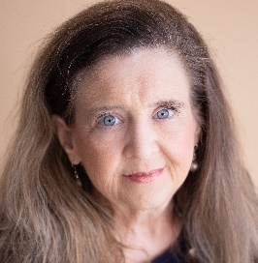
“I followed WPN’s system and have more business than I expected – and in record time! Not only did we create a brand-new line of business, by following their marketing formula and their speaking for influence coaching, I close between 30% and 60% every time.”

~ Laura Barker, JD, BarkerBusinessSolutions.com
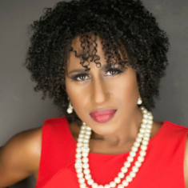
“Thanks to being “YES! READY” and the connections I made through Nancy and Trish, I landed a major media tour – radio and TV stations were calling me!”

~ Stacey Murphy, VixenAcademy.com


“Yesterday I had a video session scheduled that I totally forgot about. When the videographer showed up at my door, my first impulse was to say I'm not ready and I don't have a script. Then I thought, "wait a minute, I just got trained with WPN and did a video as well." So I jumped in without a script but knowing exactly what to say. Thank you, WPN."

~ Karina Felix, Lifestyle Living Magazine
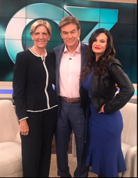
"Yes, that's me with Dr. Oz! Just one of the many places I've been to share my story. I first got the courage to share my story at WPN's Speaker Training and the rest as they say is history! Thank you to my WPN family."

~ Debby Montgomery Johnson, TheWomanBehindTheSmile.com & Benfocomplete.com

Let’s Get You YES Ready!
Go to► WomensProsperityNetwork.com/yes-ready
Or Text Susan at 954-290-2240

