

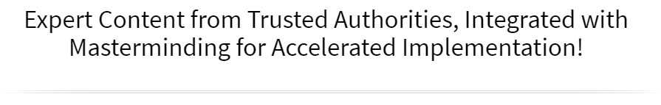



Online Workshop & Mastermind

Create Your Inspired Action Plan
Increase Your Reach, Your Impact & Your Income

June 14 & 15, 2024
Via Zoom!

►
https://zoom.us/j/9604311277
Required Meeting Password: WPN
or Dial In: 1-929-205-6099, Meeting ID 960 431 1277

Schedule (Both Days)
Please Note: Times are approximate due to the interactive nature of this experience.

 | Eastern | Central | Mountain | Pacific
Start Time | 11:00am | 10:00am | 9:00am | 8:00am
Stretch Break | 12:30 to 1245 pm | 11:15 to 11:30am | 10:15 to 10:30am | 9:15 to 9:30am
Stretch Break | 2:15 to 2:30 pm | 12:30 to 1:00pm | 11:30am to 12pm | 10:30am to 11am
Stretch Break | 3:30 to 3:45pm | 2:30 to 2:45pm | 1:30 to 1:45pm | 12:30 to 12:45pm
Event Concludes | 5:00pm | 4:00pm | 3:00pm | 2:00pm

Welcome to The Legendary Level Up Mastermind Experience

You are about to take part in our proven prosperity system designed to bring you extraordinary results in every area of your life and business. Here are some suggestions to support you in getting the most from this experience:

- Dream Big: Give yourself permission to dream big and be open to the expected and unexpected ways that your dream and goals will be realized.

- Connect & Collaborate: Make an effort to not just meet one another, but to really connect so that you can discover ways to collaborate, support each other and serve your customers even better.

- Have Fun: One of the things we learned early on from our mother was that life (and business) can and should be fun! If you’re not having fun, get back to your heart’s desire and the reason you created your business.

What Members Are Saying:

“Becoming a Member of Women’s Prosperity Network was one of the best decisions I’ve made. Thanks to the way WPN Leadership brings us together and the business development strategies they provide, our business has increased ten times! The heart and spirit of this community is women supporting each other, doing business with each other, and making a positive difference in the world together.” ~ Gladys Diaz, HeartsDesireIntl.com

“The WPN community, ideology, the leaders and their vision have profound value for anyone wanting to enrich their lives.” ~ Jodi Darren, TV Spokesperson, Entrepreneur



Levelling Up in the “Certain” Way
Your Step-by-Step System for a Business You Love & That Loves You Back!

 | “Vision without action is merely a dream. Action without vision just passes the time. Vision with action can change the world.” – Joel A. Barker (Futurist, Author, Film Maker)

Visualization Activity
How old is the future you?
What was the gift?
What color did you paint with?
What else did you observe?

Activity: It’s three (3) years from today and you are reflecting upon all the wonderful things that have happened in your life and how it has significantly improved in every area. Imagine your finances, relationships, career and health are all as you’ve always wanted them to be. Think about some of your achievements, celebrations, vacations, and exciting surprises that happened during these three (3) years.

Date: June 14, 2027

What I Would LOVE to Experience…
Write down one thing (or more) that you would love to experience in the next year:

Finances | Relationships | Health & Fitness
Career | Fun & Play Time | Contribution & Legacy
Personal Growth | Spiritual Development | Hobbies

My Intentions & Goals to Achieve by December 31, 2024
Business | Personal

Now, let’s chunk it down to specific goals.
The impact I want to have realized by December 31, 2024, is:
Example: Earn $50,000 by serving 50 or more clients
Example: Have my book published and read by 300 people
Example: 25 people have reduced their body fat and improved their overall health
Example: 1,000 women are engaged in my FB group, programs, products, and services
Example: Have delivered 25 presentations sharing my message for impact

I know I will have realized this goal when:
What is the very last step in the process of achieving this goal? What specifically will have to have happened for you to know you achieved this goal?
Example: When I look in my bank account and see $50,000 having been deposited through the year.
Success Secret
Fuel your intentions and inspired actions by knowing the
emotional and intangible factors related to achieving your goals.

Motivation

WHY I want these goals?
(the specific outcomes you are looking for)
List ALL the Benefits here (of attaining your goals)
The BIG Benefit (of achieving goals)
What is the PAIN? (of NOT achieving your goals)
Achieving this Goal will also help me (other areas)

Obstacles or Challenges

What obstacles or challenges may I encounter?
Ways to get past the obstacle(s) or challenge(s)?

What system(s) will you put in place to ensure you achieve your goals?
Goals are achieved through systems, which is a collection of small daily habits done consistently.

Marketing | Lead Generation | Content Creation | Automation | Sales
Time Mastery | Accountability | Self-Leadership | Self-Care | Spiritual Alignment

“Goals are good for setting a direction, but systems are best for making progress.”
~ James Clear (Author of Atomic Habits)

AI Prompt (example):
I have a goal to earn $50,000 between July 1st and December 31st selling services that range from $97 to $5,000. Design a daily habit system that will support achieving this goal.

Time Mastery for Business Profitability

“Time flies … the good news is that you get to be the pilot.”
~ Michael Altshuler ~

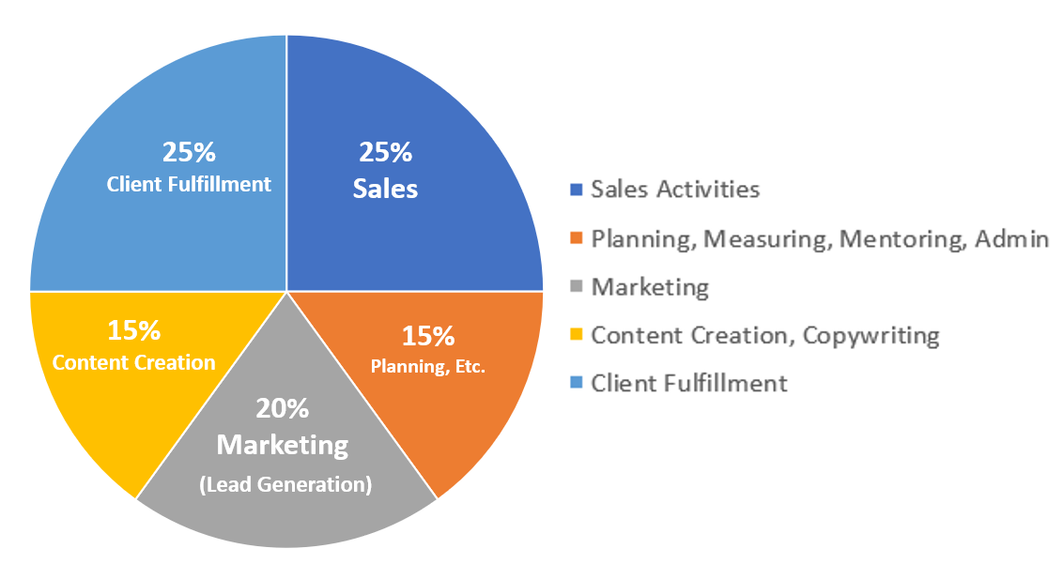

*Based on a 40 hour workweek
% | Hours | Activity
25 | 10 | Sales Conversations, Presentations & Follow Up
15 | 6 | Planning, Measuring, Learning, Mentoring, Administrative
20 | 8 | Marketing (Lead Generation) Social Media, Email, Ads, Networking
15 | 6 | Content Creation, Copywriting
25 | 10 | Client Fulfillment

Now you…
I commit to giving my vision and my business my focused attention, energy and effort for
________ hours per week.

Take the total number of hours x percentage
Example: 20 hours per week x 25% = 5 hours per week on sales activities

% | Hours | Activity
25 |  | Sales Conversations, Presentations & Follow Up
15 |  | Planning, Measuring, Learning, Mentoring, Administrative
20 |  | Marketing (Lead Generation) Social Media, Email, Ads, Networking
15 |  | Content Creation, Copywriting
25 |  | Client Fulfillment


Special Guest
Dr. Sreelatha Meleth “Dr. Sree”

Freeing Yourself from the Fear of Sales
FREE Gift – FreeingOurselves.com/SalesFear

Complimentary Session with Dr. Sree
https://calendly.com/sreelatha-meleth/lets-chat
Free Yourself & Change Your Story

List Building & Lead Generation
List Building Basics:

- Have a free gift offered on a website landing page (also called squeeze page or opt in page) offering a valuable resource to your ideal clients in exchange for them giving you their name and email address.
  - Gift Ideas: Assessments, Quizzes, Guides, PDF, eBook, short video course, infographics
- This keeps YOU in control of the communication for follow up and nurturing the relationship.

List Building Strategies:
- Blog / Article Writing – Your Site, Social Media Sites and others’ sites – much include a call to action (something free)  - Trade Shows / Expos – Drawing for Prize  - Postcards – with call to action leading to your website/free gift  - Networking Events – collect cards – do a giveaway  - Create a Referral Program for Your Clients  - Example: https://members.womensprosperitynetwork.com/referrals/  - Speak to Groups (local chambers, internet radio shows) | - Collaborate - Market for one another (email, social media)  - Take part in a Summit (as a guest speaker)  - Create an online Summit – webinar series with several of your strategic alliances  - Gift Giveaways – Host your own and take part in others (see page 2)  - Be a guest on podcasts  - Facebook Posts / Live Videos  - LinkedIn – Posts and Messages (mind your P’s & Q’s!) – See Laura Barker LinkedIn Training  - Ads – Facebook, Instagram, Google, YouTube

Use ChatGPT to Create Your Ideal Client Avatar
& Marketing Content
The magic and power of ChatGPT happens when you:
- Provide descriptive prompts to generate robust responses.
- Remember that you’re in a 2-way communication with the bot – continue probing, ask for greater (or less) detail.
- ALWAYS edit, modify and fact check any information provided by ChatGPT (or other AI software) to ensure:
  - It has YOUR voice and unique perspective.
  - Avoid the risk of copyright infringement or plagiarism.
  - Doesn’t sound like a robot!
Prompt 1:
Describe your area of expertise, who you serve, the problem you solve and/or the solution your ideal client is seeking.

Example:
I am a life coach who focuses on helping people get unstuck and inspired to move forward. Create .an ideal client avatar that includes the specific challenges that occur in their day to day lives.
Prompt 2:
(to get it to go deeper and more descriptive)

Make a list of 10 ways that these challenges affect her relationships, her weight and feelings about herself.
Prompt 3:
(to get it to go deeper and more descriptive)

Write a script for YouTube that describes a real-life challenge for this ideal client.
Prompt 4:
(to get it to go deeper and more descriptive)

Make a list of 3 things that the client’s husband might say to her that is unsupportive.
Prompt 5:
(to get it to go deeper and more descriptive)

Make a list of 3 things that the client’s best friend might say to her that is unsupportive.
Prompt 6:
(to get it to go deeper and more descriptive)

Make a list of 3 things the client thinks to herself but is afraid to share with anyone else.

Prompt 7:
(Create an opt in free gift)

Based on her challenges, create an ebook that addresses her top issues and gives quick solutions moving towards resolution of her problems.

Prompt 8:
(Create social media content)

Create 10 posts for Facebook to promote the ebook. Use humor and inspiration.

Tips & Insights from Women Just Like You!
  Valerie Ritchie |   Lisa I. Perez |   Dr. Heather Tucker

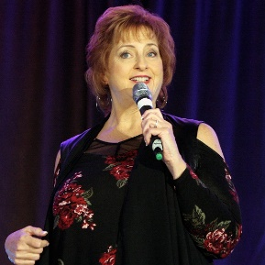
Trish Carr
Speaking for Fun & Profit


Special Guest
Kathryn Yarborough

Summit Ready Challenge (free)
A fun and useful Zoom event happening June 25th.
FREE – ManifestingClientsAcademy.com/SummitReady

Are You Summit Ready?

Insights, Takeaways & Integration

Welcome to Day 2 – Level Up!

 | My Intentions & Goals to Achieve by December 31, 2024
 | Business | Personal
Now, let’s chunk it down to specific goals.
The impact I want to have realized by December 31, 2024, is:
Example: Earn $50,000 by serving 50 or more clients
Example: Have my book published and read by 300 people
Example: 25 people have reduced their body fat and improved their overall health
Example: 1,000 women are engaged in my FB group, programs, products, and services
Example: Have delivered 25 presentations sharing my message for impact

I know I will have realized this goal when:
What is the very last step in the process of achieving this goal? What specifically will have to have happened for you to know you achieved this goal?
Example: When I look in my bank account and see $50,000 having been deposited through the year.

In order to achieve this goal, here are the daily habits and actions I give my focus, attention and energy to:

How to Build a Tribe You Can Be Proud of and that Amplifies Your Impact
“A tribe is a group of people connected to one another, connected to a leader, and connected to an idea. For millions of years, human beings have been part of one tribe or another.
A group needs only two things to be a tribe – a shared interest and a way to communicate.”
~ Seth Godin, Author of Tribes: We Need You to Lead Us

Key Ingredients to Build Your Tribe & Create a Bonfire Effect in Your Business

What is your shared interest?
What is your common cause? (What is the system, structure, or socialization factors that cause the challenge to exist?)
What is your RALLY CRY? (The message that inspires others to want to be part of your tribe?)

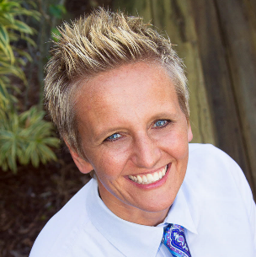
Special Guest
Jo Englesson

[re] WIRED for Peace
Transform Your Life in 6 Weeks! August 7th – September 11th

Go to: AwakenWithGratitude.com/Peace
FREE for WPN Members (normally $675!) - Use Coupon Code WPN for 100% Discount

Level Up Your Inner Game for Big Success

Deliver Value & Monetize
What You’ll Deliver (Products & Services) | How You’ll Reach People (Marketing)

Be Prepared to Serve and Receive!
Funnelology:
Creating Funnels for Maximum Impact & Income!

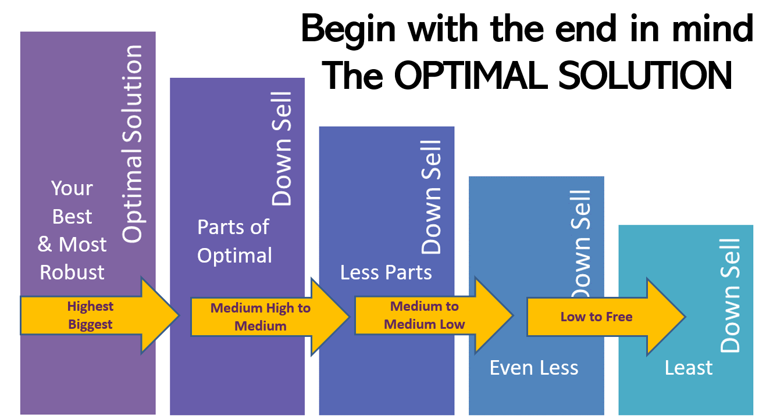

If your ideal client was sitting across from you (or on the phone/zoom), and they had the exact problem that you’re an expert at solving, what would your optimal solution be?

The optimal solution for my ideal client is:

Next, pull out pieces from the Optimal Solution to Create Smaller Offerings

High-End to Medium  $500 to $5,000 | Small to Medium  $50 to $500 | Free & Low Cost  $0 to $50

Design your business to fuel your life!
What is your financial goal?

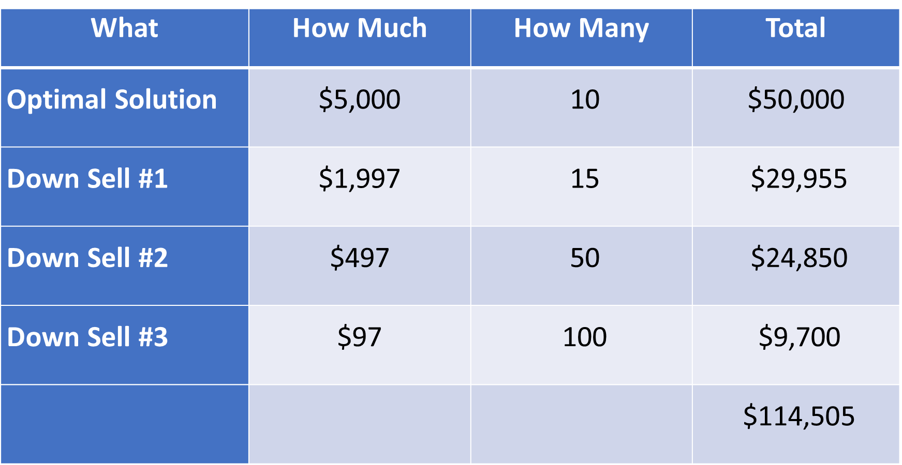

Next, your funnel defines your business activities:
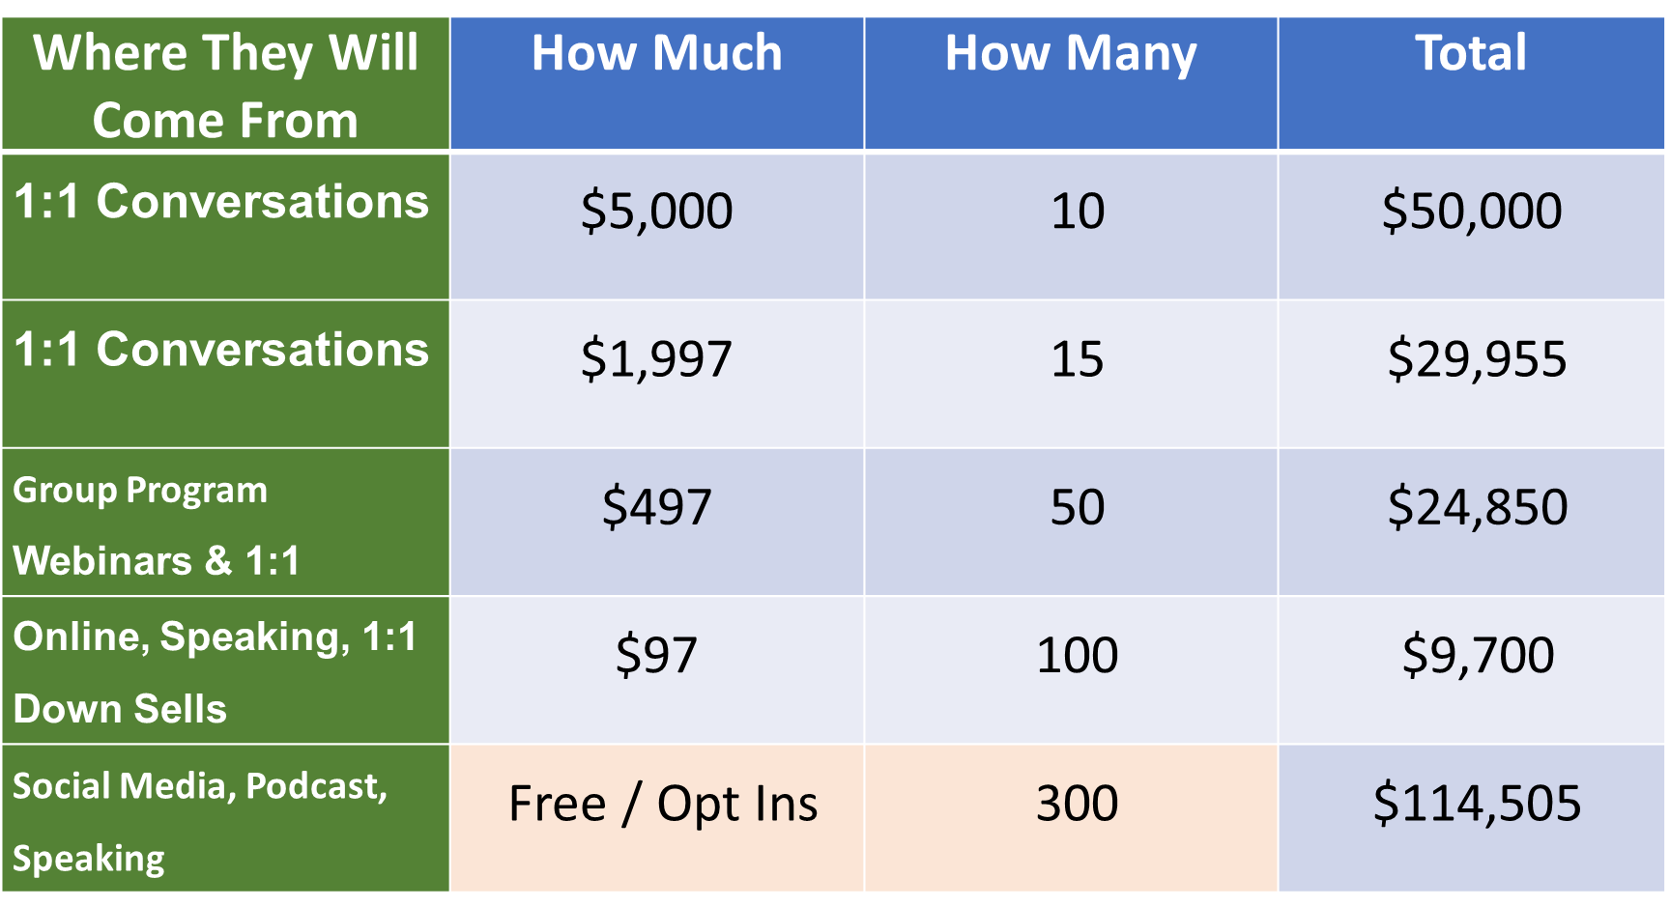


Special Guest
Dr. Patricia Rogers

Your Visibility Strategist

Get Dr. Pat’s 11 Tips to Get More Speaking Gigs Now
Go to: DrPatriciaRogers.com

Activities to Drive Results – The 2x2 System

INSTRUCTIONS: Let’s keep it simple so that you’re consistently doing 2 simple things to get booked, post content and cultivate client relationships. The top chart is an example to follow – AND Select the Days of the Week that work best for YOU!

 | Monday | Tuesday | Wednesday | Thursday | Friday
Contacts |  | Reach out to 2 new contacts for speaking, podcasts, JV’s |  |  | Follow up with 2 contacts for speaking podcasts, JV’s
Content | Post content in 2 places |  | Post content in 2 places |  | Plan next week’s content
Clients |  | 2 connection conversations |  | 2 connection conversations

Tips & Insights from Women Just Like You!

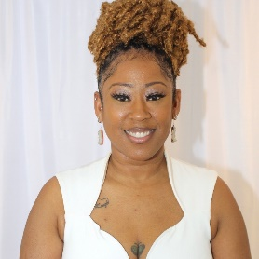  Jewana White |   Barbara Johnson | Laura Barker  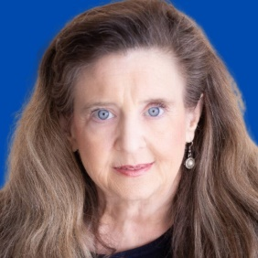

Your Inspired Action Plan
“Miracles are all around us just waiting for US to have the vision to see them.” ~ Nancy Matthews

Note: An INSPIRED action plan is rooted in doing things in “The Certain Way”

- Actions feel good.
- Every action is backed by faith and purpose.
- We are open to new opportunities and avenues for the realization of our desired vision and resulting impact for ourselves and others.

Doing things in “The Certain Way”

- Ongoing connection to your bigger purpose and impact
- Being an “advancing personality” (i.e. Being The One)
- When fear, doubt or uncertainty arise, seek support and mentoring.
- When you notice thoughts of “Well, I couldn’t possibly do that” or “It won’t work” … IMMEDIATELY ask … “What if I could?”

Become the Master of Your Energy – Pay Attention to ALL OF YOU

Personal Development & Mindset | Physical Environment & Self-Care
Intentions:  - Read / Listen Book  - Journal  - Attend Event  - Other | Intentions:  - Sleep  - Exercise  - De-Clutter  - Other
Business Goals | Spiritual Connection & High Vibration
Intentions:  - 3 Action Items Towards My Goals  - Income Generated  - Feel inspired and grateful about my work | Intentions:  - Gratitude  - Impress Upon / Connect with Infinite Substance  - Meditate

My Desired Goal / Outcome by December 31, 2024, is:

Annual | Quarterly | Monthly

Focus Forward Action Plan

 | July | August | September
3rd Quarter
Revenue Goal

Offerings

Other Milestones
#Clients
# New Contacts
# Speaking Gigs
 | October | November | December
4th Quarter
Revenue Goal

Offerings

Other Milestones
#Clients
# New Contacts
# Speaking Gigs

New Year 2025

 | January | February | March
1st Quarter
Revenue Goal

Offerings

Other Milestones
#Clients
# New Contacts
# Speaking Gigs
 | April | May | June
2nd Quarter
Revenue Goal

Offerings

Other Milestones
#Clients
# New Contacts
# Speaking Gigs

