


The Sales & Marketing Mastery Clinic

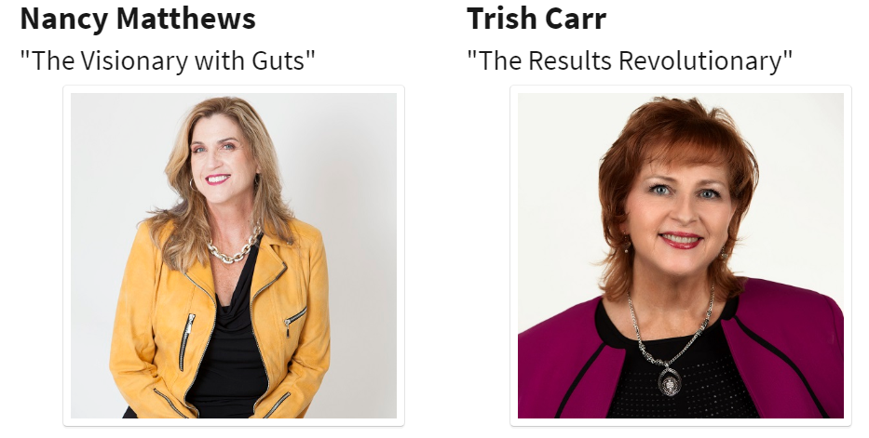


Saturday, September 27th
12 pm to 5 pm ET
Via Zoom!



Welcome to The Sales & Marketing Mastery Clinic

You are about to take part in our proven prosperity process designed to bring you extraordinary results in every area of your life and business. Here are some suggestions to support you in getting the most from this experience:

- Have a Beginner’s Mindset: “In the beginner’s mind there are many possibilities. In the expert’s mind there are few.” (Shunryu Suzuki) Having a beginner’s mind will open up new avenues and opportunities for your success.

- Dream Big: Give yourself permission to dream big and be open to the expected and unexpected ways that your dream and goals will be realized.

- Connect & Collaborate: Make an effort to not just meet one another, but to really connect so that you can discover ways to collaborate, support each other and serve your customers even better.

- Have Fun: One of the things we learned early on from our mother was that life (and business) can and should be fun! If you’re not having fun, get back to your heart’s desire and the reason you created your business.

What Members Are Saying:

“The mentoring, coaching and support of WPN has helped me to triple my income and I am serving people better than ever before.” ~ Allison Ronis, GeekInYourPocket.com

“The WPN community, ideology, the leaders and their vision have profound value for anyone wanting to enrich their lives.” ~ Jodi Darren, TV Spokesperson, Entrepreneur

“Before WPN I had a strong passion and big vision, but no plan to make it a reality. Now, Vision for Jamaica is up and running – children are being equipped with skills and resources to shape their future.” ~ LaRonda Robinson, Vision for Jamaica

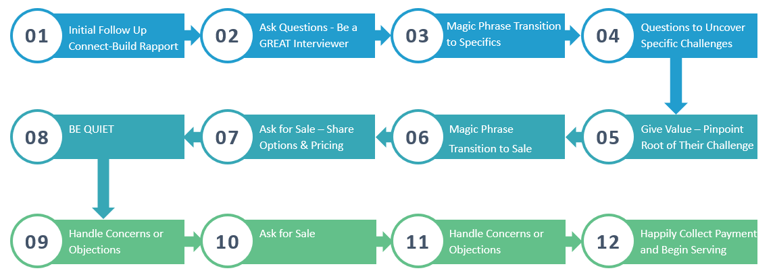

NOTES, INSIGHTS & AH-HA’S

Use ChatGPT to Know Your Ideal Client
What they want, how they think and how they talk about it.
The magic and power of ChatGPT happens when you:
- Provide descriptive prompts to generate robust responses.
- Remember that you’re in a 2-way communication with the bot – continue probing, ask for greater (or less) detail.
- ALWAYS edit, modify and fact check any information provided by ChatGPT (or other AI software) to ensure:
  - It has YOUR voice and unique perspective.
  - Avoid the risk of copyright infringement or plagiarism.
  - Doesn’t sound like a robot!

GOAL – Come up with a list of 10 questions you could ask on a first meeting with someone that will cause the person to self-identify if they have a problem or unmet desire you can help them with.

Prompt:
You are a mindset coach for business owners and teach them how to manifest their desires. Create a list of 10 potential questions you could ask someone about their lives at a networking event when you're first getting to know them. Make these questions designed to build rapport and trust and be focused on areas of their lives where the ideal client typically has challenges or unmet desires that you could help them with.

Reply to ChatGPT:

These questions are too personal and deep, revise the list of questions to be more generic about their lives by exploring the areas of their lives that are impacted by them having challenges with manifesting what they want.

Next prompt thread:

What words would my ideal client use to describe their issues?

Next prompt thread:

If they weren't aware of the underlying problem or root cause, how would they describe the problems?

Next prompt thread:

What types of things would they be saying if they were in denial?

Next prompt thread:

What could I say to them to help them gain awareness of the root problem and get them to go deeper?

Funnelology:
Creating Funnels for Maximum Impact & Income!

Begin with the end in mind.
What is the OPTIMAL solution for your client?
OPTIMAL
SOLUTION

Highest Price Point

Longest Term
Most Services

DOWNSELL

Medium Price

Includes Pieces of Optimal Solution

DOWNSELL #2

Lower Price

Includes Fewer Items
DOWNSELL #3

Lowest or Free

A Sample or 1 or 2 Pieces

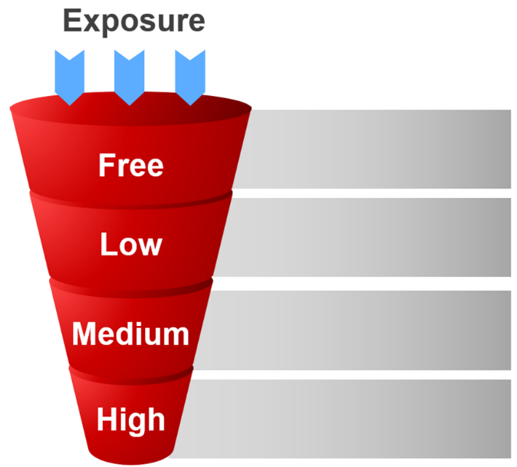

The Optimal Solution for My Ideal Client Is:

Next, pull out pieces from the Optimal Solution to Create Smaller Offerings

High-End to Medium  $500 to $5,000 | Small to Medium  $50 to $500 | Free & Low Cost  $0 to $50

Miscellaneous Ideas & Notes:
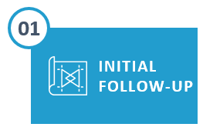 | The purpose and intention is to connect and build rapport. Remind them of where, when or how you met. Be interested in THEM.
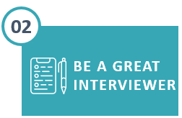 | Ask Questions about THEIR lives in the areas you know your clients typically have challenges or unmet desires
 | Once they’ve self-identified areas where you can add value, here’s where the magic happens.  Magic Phrase Transition…“I might be able to give you some ideas about that, would it be okay if I asked a couple of questions?”
 | These are more specific questions to dial in and discover their level of pain or desire so that you can best serve them. Find out what it’s costing them to not have a solution, what they’ve tried before (that did or didn’t work), This will also reveal concerns and objections even before ever asking for the sale!
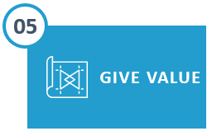 | Offer 1 or 2 tips or suggestions focused on identifying the problem area that needs attention. CAUTION: Don’t give too much advice here or they won’t see the need to continue with you. Instead they’ll want to go implement what you just gave them.
 | Pre-Requisite: You have a high level of rapport, they have said, “Yes” several times and/or have been in agreement with you and indicated they want a solution.  Magic Phrase Transition to Sale … “Would it be okay if I now share how we can continue working together?
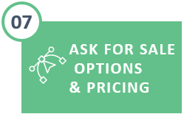 | If possible, offer 2 product options (one higher priced than the other). This gives the buyer the power of making a choice between (A) and (B) rather than a choice between Yes or No.  (Note: It’s essential you know your pricing and packaging beforehand.)
 | Silently count to yourself (6 seconds is a good rule of thumb.)  If they do not say anything, ask … “Wouldn’t you love to be able to say this time next month that this was the best decision you made because you finally got what you wanted?”
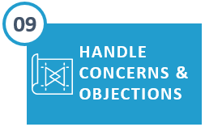 | Be Prepared – You Already Know the Most Common Concerns.  Remember, “Feel, Felt, Found” and have personal stories or client stories that demonstrate how that concern was eliminated and the resulting success or transformation.
 | “So now that you’ve realized that this is easier and simpler than you think, let’s go ahead and get started. Which credit card would you like to use?”
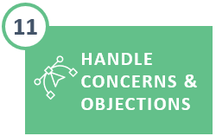 | You may experience a second round of concerns if all of theirs were not uncovered in the first round. Repeat … “Feel, Felt, Found” and ask for the sale again.
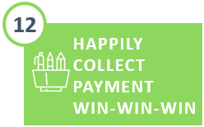 | Collect the Payment and AFFIRM THEIR GREAT DECISION using their words of how they will feel when they finally have what they want (these were already conveyed to you in Steps 2 & 4).

Let’s Practice

You’re making a follow up phone call to someone you met at an event a couple of months ago.

Go through steps 1 through 6 of the sales process.

- Connect & Build Rapport
- Be a Great Interviewer – general, non-invasive questions
- The “Magic Phrase”
  - I might be able to give you some ideas about that, would it be okay if I ask a couple of questions?
- Ask more specific questions
- Give value – focus on the WHAT not the how

Prerequisites / Assumptions
- You’ve already built rapport and they’ve said ‘YES’ several times during the conversation.
- They have self-identified a challenge and that they do want a solution
- You’ve demonstrated your expertise by giving value in terms of a tip or suggestion

Step 6: The “Magic Phrase”
  - Would it be okay if I share now how we can keep working together?

Step 7: Ask for the Sale (Options & Pricing)

  - Recap both the challenge and solution they’ve expressed to you … USE THEIR WORDS … then offer your options for getting them what they want.

Step 8: BE QUIET

For next practice round, have in mind two offerings for the client.
One high and one mid-range.

My two offerings are:

Optimal Solution | Down Sell

END YOUR CONVERSATON AT #8
Do not proceed to #9 in the process
If you have extra time – practice again
~ ~ ~ ~ ~ ~ ~ ~ ~
Handling & Eliminating Objections

“Every sale has five basic obstacles: no need, no money,
no hurry, no desire, no trust.” ~ Zig Ziglar

The three most common objections:
- I don’t have the time
- I don’t have the money
- I’m already working with someone
PRO TIP – FEEL, FELT FOUND
SUPER POWER PRO TIP
Stories of clients who had the same or similar objections, overcame them, and got great results!

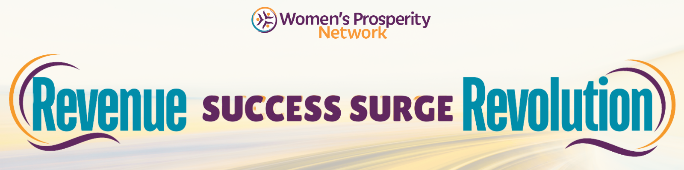
KEEP THE CONVERSATION GOING FOR MORE CONVERSIONS!

Get Your Revenue Revolution Now
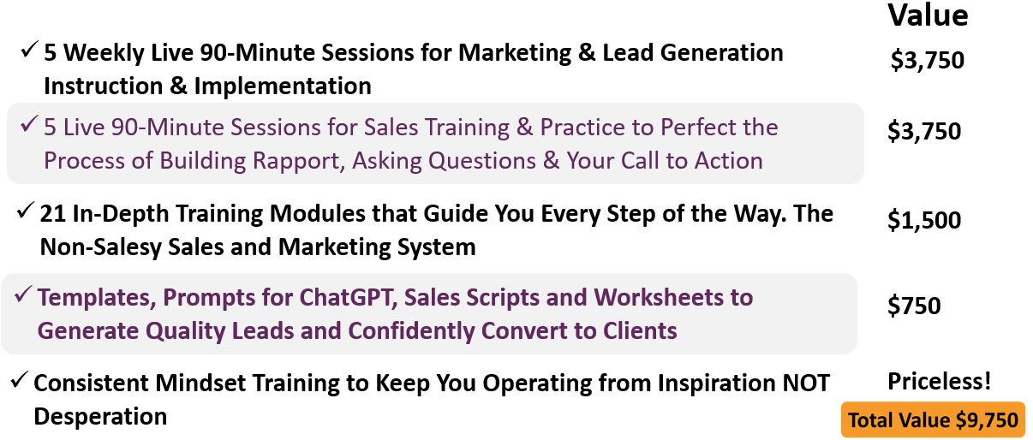


 | 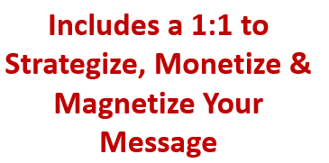

CLAIM YOUR REVENUE REVOLUTION

WOMENSPROSPERITYNETWORK.COM/SURGE

