

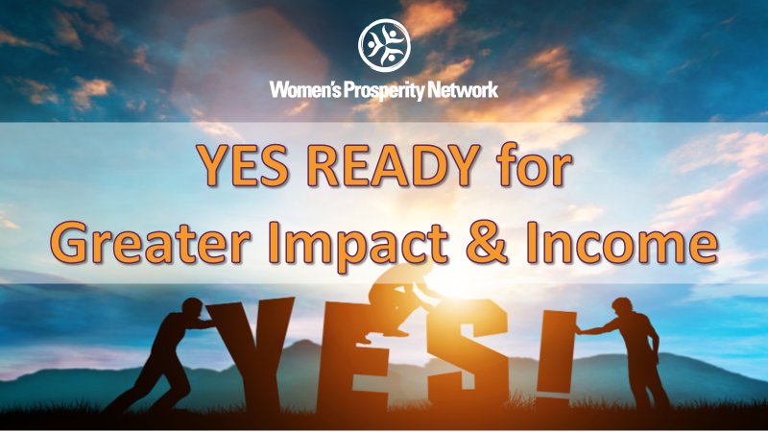

Be YES Ready for:
Greater Brand Exposure
Converting More Clients ($$$)
More Ease, Flow & Prosperity

Online Training

► https://zoom.us/j/9604311277
Password: WPN

or Dial In: 1-929-205-6099, Meeting ID 960 431 1277

What I Would LOVE to Experience…
Write down one thing (or more) that you would love to experience in the next year:

Finances | Relationships | Health & Fitness
Career | Fun & Play Time | Contribution & Legacy
Personal Growth | Spiritual Development | Hobbies

Now, let’s chunk it down to specific goals
The result I will have realized by December 31, 2025 is:
Example: Earn $50,000 by serving 50 or more clients
Example: Have my book published and read by 300 people
Example: 25 people have reduced their body fat and improved their overall health
Example: 1,000 women are engaged in my FB group, programs, products, and services
Example: Have delivered 25 presentations sharing my message for impact

I know I will have realized this goal when:
What is the very last step in the process of achieving this goal? What specifically will have to have happened for you to know you achieved this goal?
Example: When I look in my bank account and see $50,000 having been deposited through the year.
What I intend to give in return for the money I desire:

What | How Much | How Many | Total
Optimal Solution
Down Sell #1
Down Sell #2
Down Sell #3

Next Chunk It Down Monthly

 | Year to Date Totals | August | September
#Clients/Revenue
# New Contacts
# Speaking Gigs
Other Milestone
 | October | November | December
#Clients/Revenue
# New Contacts
# Speaking Gigs
Other Milestone

Activities to Drive Results – The 2x2 System
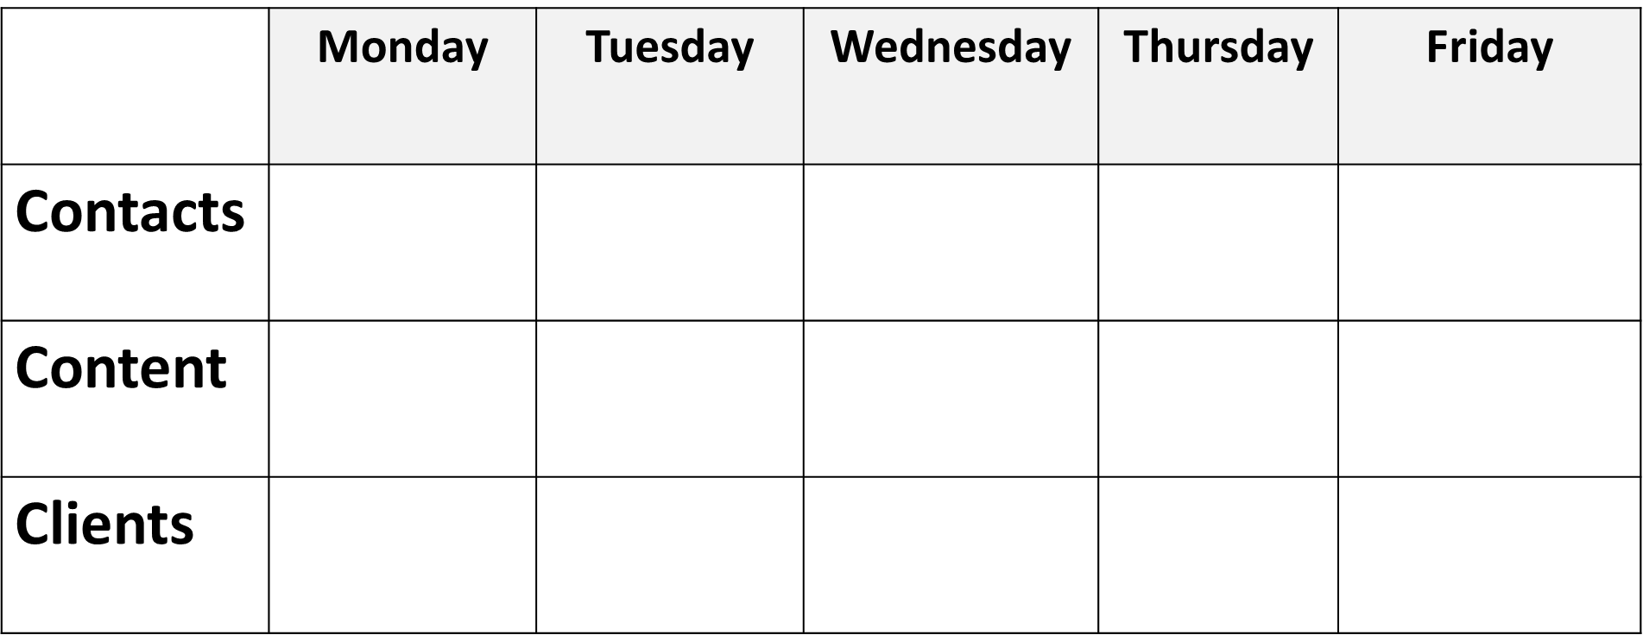

What Do I Need to Be YES Ready & Manifest My Desires?

 | Items Needed | ✓
Greater Brand Exposure  Speaking Gigs, Podcasts  Content Sharing  Joint Venture Partners | Speaker/Media One Sheet
 | Signature Talk
 | Professional Bio
 | Head Shot
 | 2 to 5 Topic Titles with Descriptions
 | System for Booking Speaking Gigs
 | Clarity & Connections for Aligned Joint Venture Partners
Convert More Clients $$$  Know My Value  Master “Magic Questions”  Be Prepared to Receive | Variety of Offerings to Serve Clients
 | Ability to Accept Payments on the Spot
 | Confidence in Asking for the Sale
 | Energy of Inspiration vs. Desperation
 | Skilled at Asking Questions & Handling Objections
Ease, Flow & Prosperity  Cast My Vision  Set Intentions  Plan & Perform  Be Consistent! | Daily Habits to Fuel My Vision
 | Systems for Support (handling obstacles)
 | Accountability
 | Mentoring
 | Steadfast Faith!

Miscellaneous Notes:

