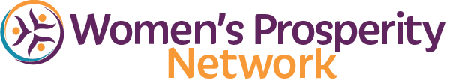



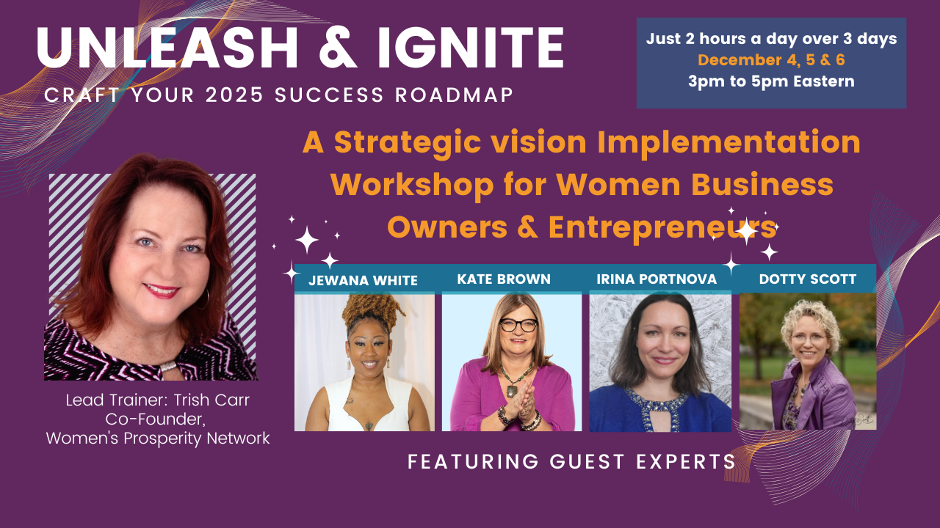

Online Workshop & Mastermind

Create Your 2025 Success Roadmap
Increase Your Reach, Your Impact & Your Income

December 4, 5 & 6, 2024
Via Zoom!

►
https://zoom.us/j/9604311277
Required Meeting Password: WPN
or Dial In: 1-929-205-6099, Meeting ID 960 431 1277

Now, let’s chunk it down to specific goals.
The impact I want to have realized by December 31, 2025, is:
Example: Earn $50,000 by serving 50 or more clients
Example: Have my book published and read by 300 people
Example: 25 people have reduced their body fat and improved their overall health
Example: 1,000 women are engaged in my FB group, programs, products, and services
Example: Have delivered 25 presentations sharing my message for impact

I know I will have realized this goal when:
What is the very last step in the process of achieving this goal? What specifically will have to have happened for you to know you achieved this goal?
Example: When I look in my bank account and see $50,000 having been deposited through the year.

My Desired Intentions/ Goals / Outcomes to Achieve by December 31, 2025:

Annual | Quarterly | Monthly

 | January | February | March
1st Quarter

Revenue Goal

Other Milestones
 | April | May | June
2nd Quarter

Revenue Goal

Other Milestones
 | July | August | September
3nd Quarter

Revenue Goal

Other Milestones
 | October | November | December
4th Quarter

Revenue Goal

Other Milestones

