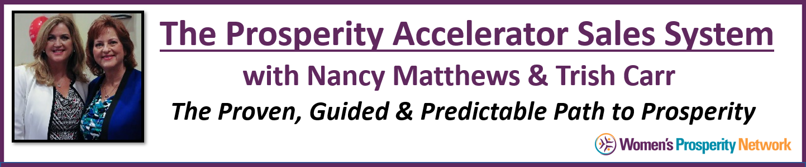

Module 2
(Preparation Worksheet)
Perfecting the Art of Listening & Asking the RIGHT Questions

The art of listening and asking the right questions begins with a thorough understanding of how your product, program or service impacts the life of your buyer, commonly referred to as the benefits. Buying decisions are first made when you are solving a problem or fulfilling a desire.
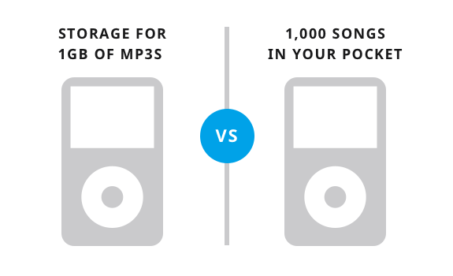
Remembering that people are listening to you through that constantly streaming radio station “WIIFM” (what’s in it for me), will keep you focused on the right language to use and the questions you ask.

While it is essential that you be well versed on all of the features, specifications and details about your products and services, the use of that information will come AFTER you have started the relationship with your prospect. Getting to the core benefits of your product or service and sharing that first with your prospects will open doors quickly and effectively to lead to building a long-lasting relationship.

Let’s begin by identifying the benefits you provide.

My Product or Service Is ___________________________________________________________

The Solution It Provides Is _________________________________________________________

_______________________________________________________________________________

_______________________________________________________________________________

Next, drill down further into how this is affecting them and their life. The more you can dial into what THEY think and say, the more you’re able to connect with them.

Note: For each problem you solve and desires you fulfill, use the below format to get into the minds and hearts of the people you want to serve.

- What words do they use to describe the problem?

- How is not having a solution impacting their day to day life?

- What are others saying to them about it?

- What else are they saying about the problem to themselves – in their mind – that they don’t easily share with other people?

One of the best ways to get to the heart of the matter is to write a testimonial letter to yourself as if you are your ideal client. Pretend that you are your client and write out a detailed testimonial that touches upon how the use of your product or service impacted your life. Focus on the tangible and intangible benefits, such as:

“Thank you Nancy and Trish! I have been a client of yours for just 30 days and am already experiencing huge results in my business. I had tried so many things before working with you, I was actually feeling a little defeated and very reluctant to spend more money. BUT … I sure am glad I did and my investment has already paid off.

I took your advice and clearly defined my target market and began spending my time networking in a full fishpond! Now, rather than feeling like I was wasting my time and wondering whether I’ll meet any potential clients at networking events, I’m wondering how I’ll fit them all into my schedule. Having you as accountability partners keeps me focused and achieving my goals. I also love the weekly group coaching calls which give me new ideas and great support. Finally, I don’t feel like I’m all alone in this business anymore. My hopes are high, my vision is restored and I ready to kick butt!

Since starting to work with you the all areas of my life have improved. Where I had a hard time getting out of bed in the morning (and falling to sleep at night cause my mind was filled with worries), I am now happy to greet the day and follow up on all the new clients I have to serve. Plus, with the great scripts you’ve provided, I don’t fumble my words or get nervous about calling people and whenever I do call to follow up --- people are actually happy to hear from me!

And, because I’m not wasting time on the wrong target market, I now have more time to spend with my family and friends. Just the other night while watching TV with my husband he turned to me and said, “Wow … you mean you don’t have to be on your computer tonight? This is great.” (You can imagine how good the night got after that .

I am finally relaxed and confident that the business will continue to flow – I’m working smarter instead of harder. Oh, yes – I forgot to tell you. From all the new business I got this last month, I now have enough money to take my dream trip to Europe this summer! Thanks again Nancy and Trish, I just love working with you and living my life to the fullest!”

Notice that throughout the testimonial letter we cited both tangible (more clients, more time and more money), and intangible benefits (less stress, more enjoyment with family and friends, no longer alone).

Added Bonus from this Exercise: You can use the language from the testimonial letter in marketing materials. You’ll be able to re-purpose this for your website, brochures, speaking presentations and of course during you one-on-one conversations.

Ready ... Set … It’s Your Turn!

Testimonial Letter to Yourself

That activity should give you some great insight into what your ideal clients are experiencing both before working with you (i.e. the problems they have) and afterwards enjoying their improved life from the benefits you provide. From the activities above, go ahead and make a list of the BENEFITS of your products and services:

Feature | Benefits
Example:  Accountability | I don’t feel alone any more  I am supported and achieving my goals

That’s it for now. We’ll see you on Tuesday!

Note: The portion at the bottom of this page will be for use during the live session on Tuesday. If you want to go ahead and fill in the blanks now … have at it!

PSA SALES PROCESS:

Step 1 – Problem: What Problem are You Solving?

Step 2 – Solution: How are you the Solution?

Step 3 – Action: What do you want the person to do now?

Next … put it all together

Your Job Is to be a GREAT Interviewer!

Your job is to find the right questions to ask so THEY SEE the problem without you having to tell them they have it.

What are the problems that your prospect may have that you could be the solution for?

For example, as a business coach, I know that the problems my clients face most often are:

- Not making enough profit
- Not enough or not having the right resources to get the job done efficiently and effectively
- Not having work and life balance

I invite you now to consider your product and/or service (pick one or a package) and jot down:

What are 3 problems you solve?

- _____________________________________________________________________
- _____________________________________________________________________
- _____________________________________________________________________

What are great questions you can ask so that they tell you what’s going on in their lives related to the area you’re an expert in?

From the example above, questions that could get to what their problems are could be:

(Remember … this is still part of the connecting conversation – getting to know each other, and these questions are designed to discover if there is a need or desire you can fulfill. Take it slow and trust the process – going too fast in the beginning of a relationship can end up as a strike out or a one- night stand. Taking your time here allows for nurturing a long-time relationship and repeat business.)

#1 Not making enough profit | - How are things going for you through the summer months? I know a lot of my clients go through some dips.  - Have you taken any fun vacations or trips lately? (if they say no – it may well mean cash or time crunches in their lives, good for #3 below too)  - What’s your favorite thing about being an entrepreneur? (this is good to put them in a happy mood – and if they can’t find something – a good clue they need you)  - What’s your least favorite thing about being an entrepreneur?
#2 Not enough money for or not having the right resources to get the job done efficiently and effectively | - Is it just you in the business or do you have others that work with you?  - I’m thinking about adding a Virtual Assistant, have you worked with VA’s in the past?  - Isn’t it great that we have so many ways to market our businesses – especially on social media? (this could likely trigger == yeah, it’s great but who has the time to do it all)  - What social media sites are you focusing on? How’s it working?
#3 Not having work life balance | - Tell me a little more about you … what do you like to do in your time off? (…I often get .. what time off?!)  - Just the other day I treated myself to a massage (or something similar – as long as it’s true) – You know – entrepreneurs like us are the crazy people willing to work 100 hours a week just so they don’t have to work 40 for someone else! – what do you do to balance it out?  - What’s your favorite thing about being an entrepreneur? (this is good to put them in a happy mood – and if they can’t find something – a good clue they need you)  - What’s your least favorite thing about being an entrepreneur?

Listening Between the Lines:

As you move to sharing about how you work with people (or companies), start from the big picture mission of why and how you serve people … each phase going deeper into detail as you gain more and more agreement and ‘buy in’ from the prospect.

