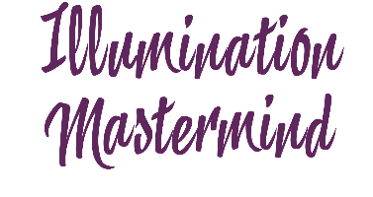
Weekly Intentions & Self-Monitoring for Consistent Progress

Week of _____________________

Personal Development & Mindset | Physical Environment & Self-Care
Intentions:  - Read / Listen Book  - Journal  - Attend Event  - Other | Intentions:  - Sleep  - Exercise  - De-Clutter  - Other
Reflection & Check In  - Learnings, Take Away’s, Ah-Ha’s | Reflection & Check In
Business Goals | Spiritual Connection & High Vibration
Intentions:  - 3 Action Items Towards My Goals  - Income Generated  - Feel inspired and grateful about my work | Intentions:  - Gratitude  - Impress / Connect with Infinite Substance  - Meditate
Reflection & Check In | Reflection & Check In

Weekly Reflection Summary
Did I perform with excellence this past week?

Did I live up to my values and expectations for giving my best and doing a good job?

What (if anything) got in my way?

What I learned about myself this week?

What I feel successful about this week?

