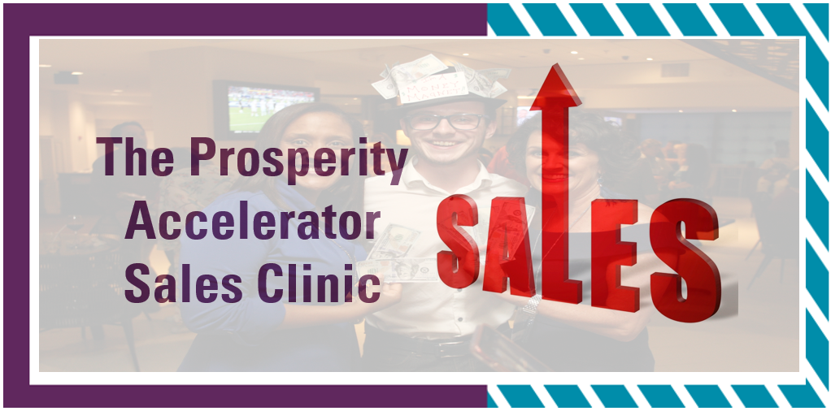

The Heart-Centered Sales Mastery Workshop

The Proven Formula for Increasing
Sales & Loving Every Minute of It!

The Heart-Centered Sales Formula
Perfecting the Art of Listening and Asking the Right Questions

My product or service is:
The solution it provides is:
What words does my customer use to describe the problem?
How is not having a solution impacting their day to day life?
What are others saying to them about it?
What else are they saying about the problem to themselves (in their mind) that they don’t easily share with others?
What questions can you ask that will have them reveal if they have a problem in an area you solve?
In a casual, non-invasive way?
Example: Business Coach | Problem – Not Making Enough Money
Question: What fun trips or vacations have you taken lately?
Question: What’s your favorite thing about being an entrepreneur?
Questions: What’s your least favorite thing about being an entrepreneur?
Question: How’s business for you through the holidays? I know it can slow down for some.

Revenue Model

Your Services, Products & Pricing
How You Serve Them & How They Pay You

“Determine exactly what you intend to give in return for the money you desire.”
~ Napoleon Hill

List Products Here  (Physical as well as Digital Products) | Pricing
List Programs or Services Here  Group Programs, 3 Month, Year-Long, Etc. | Pricing
List Packages Here  i.e. Bundling of products, services and programs or other offerings | Pricing

Funnelology:
Creating Funnels for Maximum Impact & Income!

Begin with the end in mind.
What is the OPTIMAL solution for your client?
OPTIMAL
SOLUTION

Highest Price Point

Longest Term
Most Services

DOWNSELL

Medium Price

Includes Pieces of Optimal Solution

DOWNSELL #2

Lower Price

Includes Fewer Items
DOWNSELL #3

Lowest or Free

A Sample or 1 or 2 Pieces

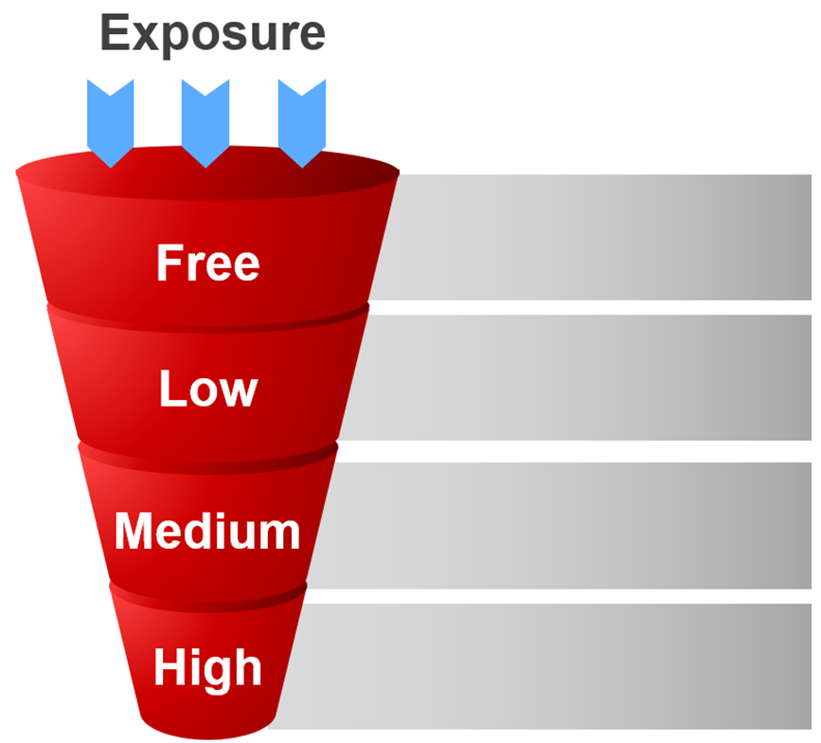

The Heart-Centered Sales Formula
The “Magic Phrase” for Smooth Transition to the Sale

Pre-Requisite: You have a high level of rapport, they have said, “Yes” several times and/or have been in agreement with you and have indicated they want a solution.
The Magic Phrase Is …
Notes & Inspired Ideas

The Heart-Centered Sales Formula
Handling & Eliminating Objections

“Every sale has five basic obstacles: no need, no money,
no hurry, no desire, no trust.” ~ Zig Ziglar

The three most common objections:
- I don’t have the time
- I don’t have the money
- I’m already working with someone
PRO TIP – FEEL, FELT FOUND

