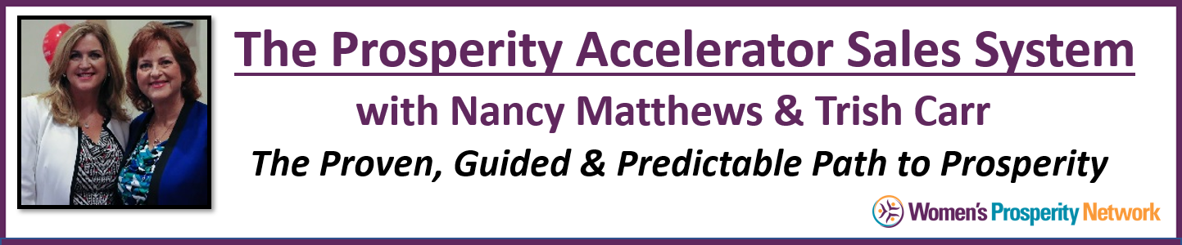
The Heart-Centered Sales Formula
Perfecting the Art of Listening and Asking the Right Questions

My product or service is:
The solution it provides is:
What words does my customer use to describe the problem?
How is not having a solution impacting their day to day life?
What are others saying to them about it?
What else are they saying about the problem to themselves (in their mind) that they don’t easily share with others?
What questions can you ask that will have them reveal if they have a problem in an area you solve?
In a casual, non-invasive way?
Example: Business Coach | Problem – Not Making Enough Money
Question: What fun trips or vacations have you taken lately?
Question: What’s your favorite thing about being an entrepreneur?
Questions: What’s your least favorite thing about being an entrepreneur?
Question: How’s business for you through the holidays? I know it can slow down for some.

