Module I – The Prosperity Accelerator Sales Training

Your Programs, Products & Pricing
How You Serve Them & How They Pay You

List Products Here  (Physical as well as Digital Products) | Pricing

List Programs Here  Group Programs, 3 Month, Year-Long, Etc | Pricing

List Packages Here  i.e. bundling of products and programs or other offerings | Pricing

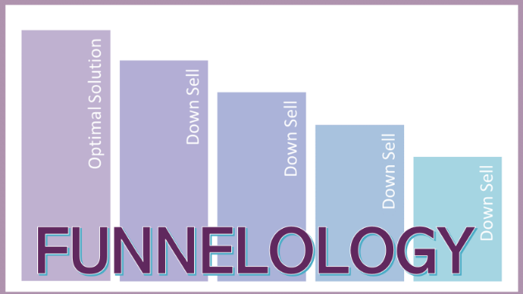

Begin with the end in mind.

If you were with your IDEAL CLIENT and they were ready, willing and able to move forward to get their desired result (transformation) working with you, how would you work with them?

YOUR OPTIMAL SOLUTION?

Description of Services / Products | Price & Benefits to Them

Next, remove pieces from your Optimal Solution for a lower priced, less comprehensive package.
(Down Sell #1)

Description of Services / Products | Price & Benefits to Them

Next, remove pieces from your Optimal Solution for a lower priced, less comprehensive package.
(Down Sell #2)

Description of Services / Products | Price & Benefits to Them

Next, remove pieces from your Optimal Solution for a lower priced, less comprehensive package.
(Down Sell #3)

Description of Services / Products | Price & Benefits to Them

Next, remove pieces from your Optimal Solution for a lower priced, less comprehensive package.
(Down Sell #4 – Free or Super Low Cost)

Description of Services / Products | Price & Benefits to Them

