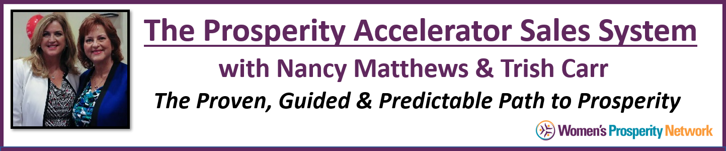

Preparation Worksheet
Handling & Eliminating Objections

“Every sale has five basic obstacles: no need, no money,
no hurry, no desire, no trust.” ~ Zig Ziglar

Objections can arise at different times during the conversation and what’s essential is that you have been carefully listening to what’s going on in their lives every step of the way so that you are best prepared if and when an objection arises.

The three most common objections are:
- I don’t have the time
- I don’t have the money
- I’m already working with someone

During our next session we will guide you in eliminating those objections so that you can serve more people by having them see the advantage of overcoming that obstacle now!

In addition to the above 3 objections, we will also cover responses to the following:

- Let me think about it
- I have to ask my spouse
- I've already got what I need
- I’m not ready
- I’ll get back to you

And, of course … if there are any other’s that you’ve encountered, bring them to the table!
The best way to handle concerns and objections is by sharing stories – personal ones and those of your clients who had similar concerns. For each objection below, find a story of either yourself or a client who had that issue initially and was able to dissolve or overcome it.

Example: I don’t have the time.
I can only imagine how you feel…
One of my clients, Mary Smith, who’s had real success in her business and was super busy, felt that way too before we started working together. What she found was that this was easier than she thought to fit into her already busy life. In fact … from some of the things she learned working with us, she reclaimed time and had more time for *fun!

Notice the “Fee, Felt, Found” structure of the response.

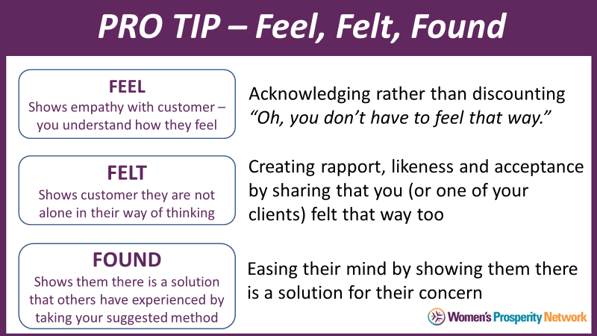

For each objection listed below (and any others you experience), share a personal story or client experience.

