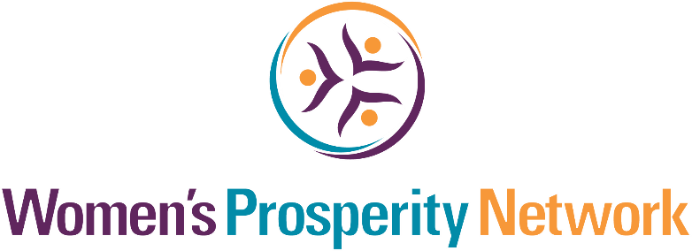

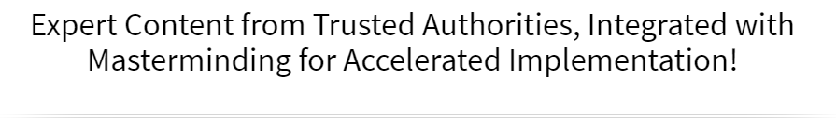

Let’s Play, Create & Manifest Your Desires for 2020 and Beyond

It’s time to …
June 26, 2020

►
https://zoom.us/j/96708484341
Password: WPN
or Dial In: 929-205-6099, Meeting ID 94967 0848 4341

Hosted by Women’s Prosperity Network
Co-Founder & Master Trainer, Nancy Matthews
Welcome to Recast Your 2020 Vision

You are about to take part in our proven prosperity process designed to bring you extraordinary results in every area of your life and business. Here are some suggestions to support you in getting the most from this experience:

- Have a Beginner’s Mindset: “In the beginner’s mind there are many possibilities. In the expert’s mind there are few.” (Shunryu Suzuki) Having a beginner’s mind will open up new avenues and opportunities for your success.

- Dream Big: Give yourself permission to dream big and be open to the expected and unexpected ways that your dreams and goals will be realized.

- Connect & Collaborate: Make an effort to not just meet one another, but to really connect so that you can discover ways to collaborate, support each other and serve your customers even better.

- Have Fun: One of the things we learned early on from our mother was that life (and business) can and should be fun! If you’re not having fun, get back to your heart’s desire and the reason you created your business.

What Members Are Saying:

“Thank you for another amazing event. It's so comforting and at the same time energizing to mastermind with other like-minded, rock star professionals looking for new ideas to serve and do MORE in the current environment. Serving the community in this newer, braver world is best done with women that can pivot and elevate to more power-full ways to serve. Thanks again!” ~ Mary Palmer, Power Glam | Mary Kay Cosmetics

“The WPN community, ideology, the leaders and their vision have profound value for anyone wanting to enrich their lives.” ~ Jodi Darren, TV Spokesperson, Entrepreneur

“Everyone I’ve worked with over the past 4 years has come from Women’s Prosperity Network community which speaks not only to the availability but also the quality of the connections.” ~ Amy Szumstein | HolisticHealingwithAmy.com

The Quintessential Equation for
Recasting Your Vision & Creating REAL Results

Notes, Ideas & Insights
Essential #1 ________ Vision

What I Would LOVE to Experience…
Write down one thing (or more) that you would love to experience by 12/31/20

Financial | Relationships
Career | Personal Goals  (learning, spirituality, individual growth):
Fun Time, Play Time | Contribution & Legacy
Health & Fitness | Other

Essential #2 ________ Vision

“I am prepared to serve AND receive!”

Your Services, Products & Pricing
How You Serve Them & How They Pay You
“Determine exactly what you intend to give in return for the money you desire.”
~ Napoleon Hill

List Products Here  (Physical as well as Digital Products) | Pricing
List Programs or Services Here  Group Programs, 3 Month, Year-Long, Etc. | Pricing
List Packages Here  i.e. Bundling of products, services and programs or other offerings | Pricing

Essential #3 ________ Vision

“I face and embrace all parts of me so that my higher self informs and inspires my actions.” ~ Nancy Matthews

Obstacles | Limitations | Challenges | What If That WASN’T So?

Notes, Ideas & Insights
Inspired Action Plan for July to December 2020

Write Your SMART Goal Here ________________________________________________ by 12/31/20

Criteria of Success:
I will know I achieved this goal when:

Set Goal Levels
MINIMUM
TARGET
STRETCH

Review, Revise & Recap – See How Far You’ve Come Already
(Remember, measuring allows us to adjust the plan to achieve the goal (regardless of what may have shown up along the way.)

Track Your Results So Far

Revenue | Other Milestones/Achievements | Potential Revenue & Opportunities

Going forward for this planning sheet, use the TARGET goal
For a monetary goal, subtract the revenue received thus far and subtract from your total goal, then break the remainder into quarters and then months

To achieve this goal, I am forecasting and planning the following milestones

Total 3rd Quarter Goal  (by 9/30/20) | July | August | September
Total 4th Quarter Goal  (by 12/31/20) | October | November | December

What knowledge, skills and abilities will help me achieve this goal? | What habits, beliefs and character traits will support my achieving this goal:

My Success Team:
Where will I gain the new knowledge, training and support to hold me accountable so that I achieve what I set out to achieve?

What challenges may I encounter? | How might I get past the challenge?

“Without clearly defined goals, we are slaves to circumstances and daily trivia.”
~Trish Carr

Notes, Ideas & Insights

“The focus Momentum has on accountability is critical and missing from most programs I have participated in. Great program!!
~ Dr. Bob Levine

“An excellent program allowing us to network/connect with each other; bolster anyone who needs it and opportunities for laser coaching is invaluable. I recommend it highly to anyone who may be sitting the fence.”
~ Debra Morrison

“Momentum is incredible! =) Saved my business!”
~ Regena Rosa-Celeste
ENROLLMENT NOW OPEN
We only open enrollment quarterly to ensure quality results, continuous progress and meaningful connections for all Members.)
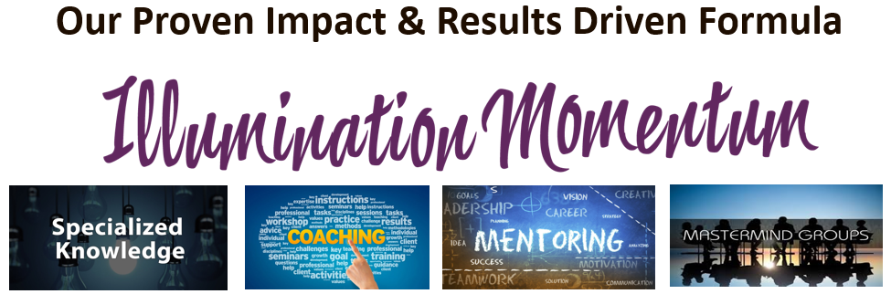
What others are saying about being in MOMENTUM:

“I don’t even focus on MONEY ANYMORE because IT KEEPS COMING!!
~ Cheri Martin

“I highly recommend this program because having Nancy & Trish guide me is like having a guide when traveling forward thru uncharted territory of launching or growing my business! Joining this training and support system is like giving myself a gift!
~Aneta

“You are so connected Nancy, to where we are in our business that you can always ground us and keep us focused on the next right thing.”
~ Linda Fostek

“I love Momentum Monday. I learn new ideas from everyone, not only from Nancy, the support and accountability is perfect for me.”
~ Sally DiCesare

ENROLLMENT NOW OPEN
Get ongoing coaching, mentoring and high-level masterminding with MOMENTUM!

Call or Text 954-290-2240

► WomensProsperityNetwork.com/Impact

