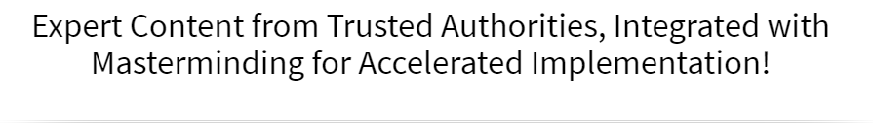
The Sales & Marketing Mastery Boot Camp

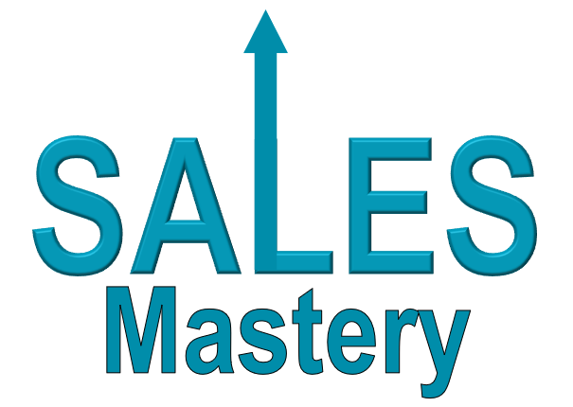

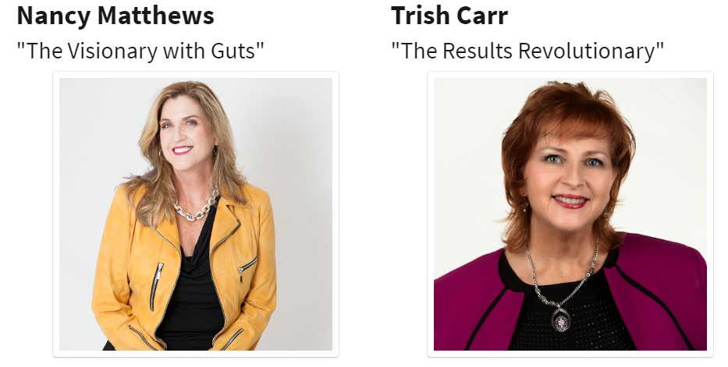

October 8th & 9th
12 pm to 5 pm ET
Via Zoom!
► https://zoom.us/j/9604311277 Password: WPN
or Dial In: 929-205-6099, Meeting ID 944 8764 1669
Welcome to The Sales & Marketing Mastery Boot Camp

Workbook – Day 1 (October 8th)
You will receive the workbook for Day 2 on the morning of the 10th.

You are about to take part in our proven prosperity process designed to bring you extraordinary results in every area of your life and business. Here are some suggestions to support you in getting the most from this experience:

- Have a Beginner’s Mindset: “In the beginner’s mind there are many possibilities. In the expert’s mind there are few.” (Shunryu Suzuki) Having a beginner’s mind will open up new avenues and opportunities for your success.

- Dream Big: Give yourself permission to dream big and be open to the expected and unexpected ways that your dream and goals will be realized.

- Connect & Collaborate: Make an effort to not just meet one another, but to really connect so that you can discover ways to collaborate, support each other and serve your customers even better.

- Have Fun: One of the things we learned early on from our mother was that life (and business) can and should be fun! If you’re not having fun, get back to your heart’s desire and the reason you created your business.

What Members Are Saying:

“The mentoring, coaching and support of WPN has helped me to triple my income and I am serving people better than ever before.” ~ Allison Ronis, GeekInYourPocket.com

“The WPN community, ideology, the leaders and their vision have profound value for anyone wanting to enrich their lives.” ~ Jodi Darren, TV Spokesperson, Entrepreneur

“Before WPN I had a strong passion and big vision, but no plan to make it a reality. Now, Vision for Jamaica is up and running – children are being equipped with skills and resources to shape their future.” ~ LaRonda Robinson, Vision for Jamaica

Who They Are
Demographics  (Age, Income, Married, Kids) | Psychographics  (Attitudes, Values, Fears) |  | Behavioral  (Habits, Hobbies, Lifestyle)
What They Want?
(As it relates to your products and services)
Problem / Pain Points |  | Solution / Desired Outcome
i.e Business not making money |  | i.e. Steady flow of qualified leads & clients
i.e. Overweight |  | i.e. Lose 20 pounds
What’s the IMPACT of the Problem? |  | What’s the IMPACT of the Solution?
i.e. May have to get a job, feels like a failure, lots of credit card debt, exhausted, always trying to work, husband threatening to divorce |  | i.e. Feels successful, able to pay off credit cards, take vacation, get hair & nails done, retire husband, philanthropy, fulfilled, confident and happy
i.e. Doesn’t go out with friends, feels depressed, ugly, unlovable, won’t do videos/speaking to grow business, feels tired all the time, irritable |  | i.e. Feels GREAT about herself, loves to get dressed up, has more energy for family, friends and work, eager to share her message in public
How They Think & Talk About It
Problem / Pain Points |  | Solution / Desired Outcome
What words does my customer use to describe the problem/solution?
What else are they saying about the problem to themselves
(in their mind) that they don’t easily share with others?
What are others saying to them about it?

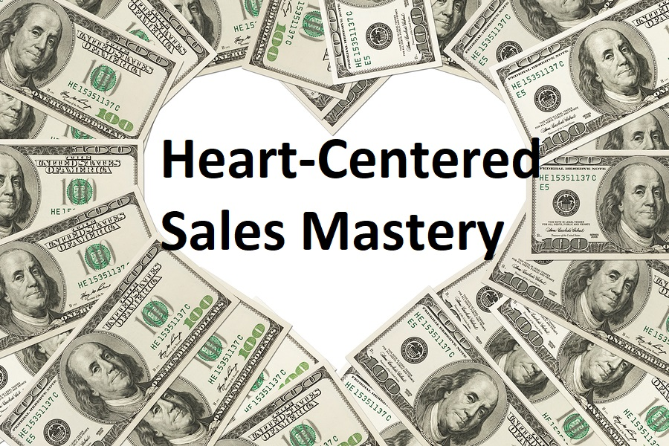

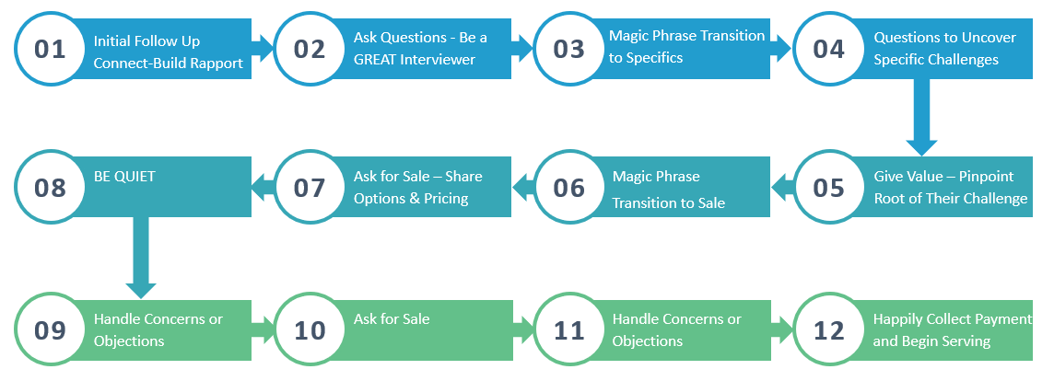

Funnelology:
Creating Funnels for Maximum Impact & Income!

Begin with the end in mind.
What is the OPTIMAL solution for your client?
OPTIMAL
SOLUTION

Highest Price Point

Longest Term
Most Services

DOWNSELL

Medium Price

Includes Pieces of Optimal Solution

DOWNSELL #2

Lower Price

Includes Fewer Items
DOWNSELL #3

Lowest or Free

A Sample or 1 or 2 Pieces

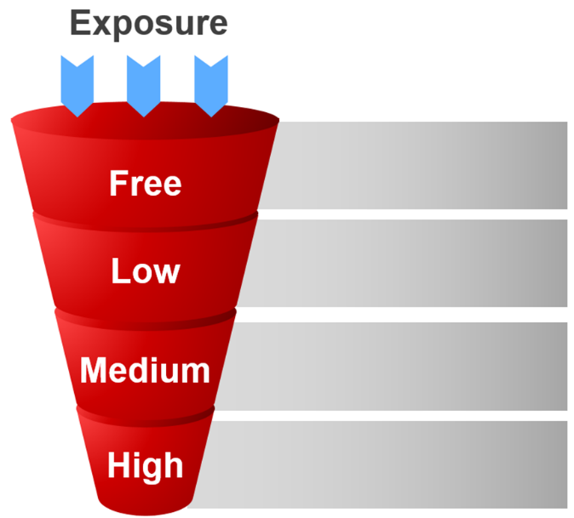

The Optimal Solution for My Ideal Client Is:
Next, pull out pieces from the Optimal Solution to Create Smaller Offerings

High-End to Medium  $500 to $5,000 | Small to Medium  $50 to $500 | Free & Low Cost  $0 to $50

Miscellaneous Ideas & Notes:
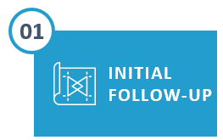 | The purpose and intention is to connect and build rapport. Remind them of where, when or how you met. Be interested in THEM.
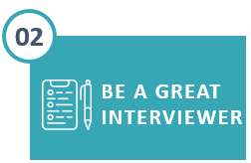 | Ask Questions about THEIR lives in the areas you know your clients typically have challenges or unmet desires
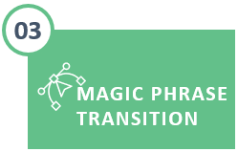 | Once they’ve self-identified areas where you can add value, here’s where the magic happens.  Magic Phrase Transition…“I might be able to give you some ideas about that, would it be okay if I asked a couple of questions?”
 | These are more specific questions to dial in and discover their level of pain or desire so that you can best serve them. Find out what it’s costing them to not have a solution, what they’ve tried before (that did or didn’t work), This will also reveal concerns and objections even before ever asking for the sale!
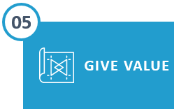 | Offer 1 or 2 tips or suggestions focused on identifying the problem area that needs attention. CAUTION: Don’t give too much advice here or they won’t see the need to continue with you. Instead they’ll want to go implement what you just gave them.
Pre-Requisite: You have a high level of rapport, they have said, “Yes” several times and/or have been in agreement with you and indicated they want a solution.
Magic Phrase Transition to Sale … “Would it be okay if I now share how we can continue working together?
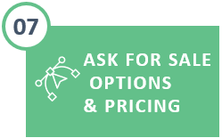 | If possible, offer 2 product options (one higher priced than the other). This gives the buyer the power of making a choice between (A) and (B) rather than a choice between Yes or No.  (Note: It’s essential you know your pricing and packaging beforehand.)
Silently count to yourself (6 seconds is a good rule of thumb.)
If they do not say anything, ask … “Wouldn’t you love to be able to say this time next month that this was the best decision you made because you finally got what you wanted?”
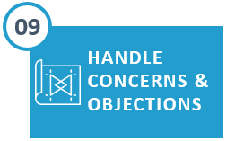 | Be Prepared – You Already Know the Most Common Concerns.  Remember, “Feel, Felt, Found” and have personal stories or client stories that demonstrate how that concern was eliminated and the resulting success or transformation.
 | “So now that you’ve realized that this is easier and simpler than you think, let’s go ahead and get started. Which credit card would you like to use?”
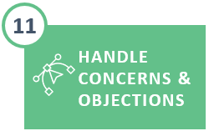 | You may experience a second round of concerns if all of theirs were not uncovered in the first round. Repeat … “Feel, Felt, Found” and ask for the sale again.
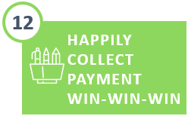 | Collect the Payment and AFFIRM THEIR GREAT DECISION using their words of how they will feel when they finally have what they want (these were already conveyed to you in Steps 2 & 4).

Perfecting the Art of Listening and Asking the Right Questions

Revisit your answers on page 3

What questions can you ask that will have them reveal if they have a problem in an area you solve?
In a casual, non-invasive way?
Example: Business Coach | Problem – Not Making Enough Money

Question: What fun trips or vacations have you taken lately?
Question: What’s your favorite thing about being an entrepreneur?
Questions: What’s your least favorite thing about being an entrepreneur?
Question: How have you been doing during this pandemic? I know it can slow down for some.

Miscellaneous Ideas & Notes:

