


The Sales & Marketing Mastery Boot Camp

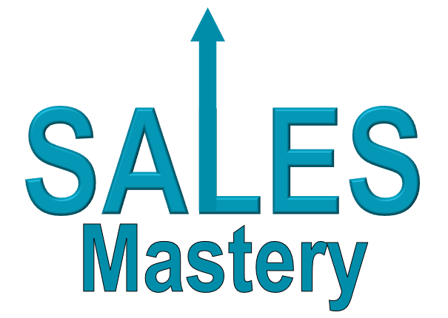 | 

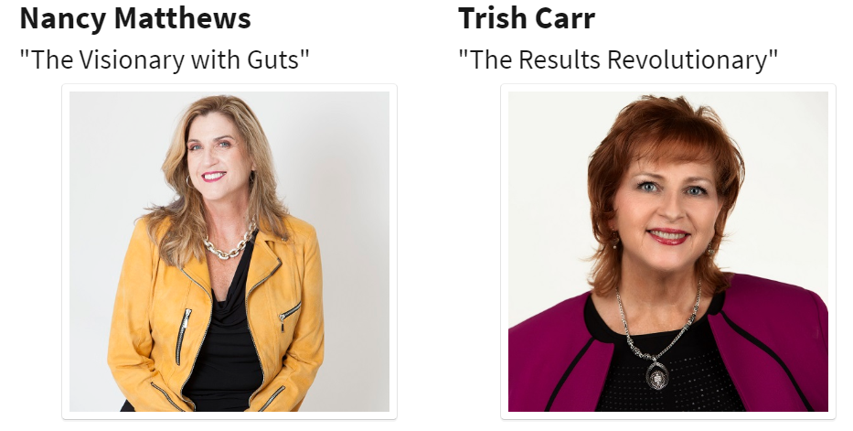


April 22nd & 23rd
12 pm to 5 pm ET
Via Zoom!
►
https://zoom.us/j/9604311127, Password: WPN
or Dial In: 929-205-6099, Meeting ID 960 431 1127
Welcome to Day 2 of The Sales & Marketing Mastery Boot Camp

Workbook – Day 2 (April 23rd)

Recap Notes:

Let’s Practice

You’re making a follow up phone call to someone you met at an event a couple of months ago.

Go through steps 1 through 6 of the sales process.

- Connect & Build Rapport
- Be a Great Interviewer – general, non-invasive questions
- The “Magic Phrase”
  - I might be able to give you some ideas about that, would it be okay if I ask a couple of questions?
- Ask more specific questions
- Give value – focus on the WHAT not the how
- The “Magic Phrase”
  - Would it be okay if I share now how we can keep working together?

END YOUR CONVERSATON AT #6
Do not proceed to #7 in the process
If you have extra time – practice again
~ ~ ~ ~ ~ ~ ~ ~ ~

For next practice round, have in mind two offerings for the client.
One high and one mid-range.

My two offerings are:

Optimal Solution | Down Sell

Prerequisites / Assumptions
- You’ve already built rapport and they’ve said ‘YES’ several times during the conversation.
- They have self-identified a challenge and that they do want a solution
- You’ve demonstrated your expertise by giving value in terms of a tip or suggestion

Picking up from number 6, continuing the conversation:

Step 6: The “Magic Phrase”
  - Would it be okay if I share now how we can keep working together?

Step 7: Ask for the Sale (Options & Pricing)

  - Recap both the challenge and solution they’ve expressed to you … USE THEIR WORDS … then offer your options for getting them what they want.

Step 8: BE QUIET

END YOUR CONVERSATON AT #8
Do not proceed to #9 in the process
If you have extra time – practice again
~ ~ ~ ~ ~ ~ ~ ~ ~

Handling & Eliminating Objections

“Every sale has five basic obstacles: no need, no money,
no hurry, no desire, no trust.” ~ Zig Ziglar

The three most common objections:
- I don’t have the time
- I don’t have the money
- I’m already working with someone
PRO TIP – FEEL, FELT FOUND
SUPER POWER PRO TIP
Stories of clients who had the same or similar objections, overcame them, and got great results!

Marketing to Attract Your Ideal Clients

Top 21 Marketing Strategies
Put a ✓ next to the ones you are consistently doing
(i.e. on a monthly or weekly basis)
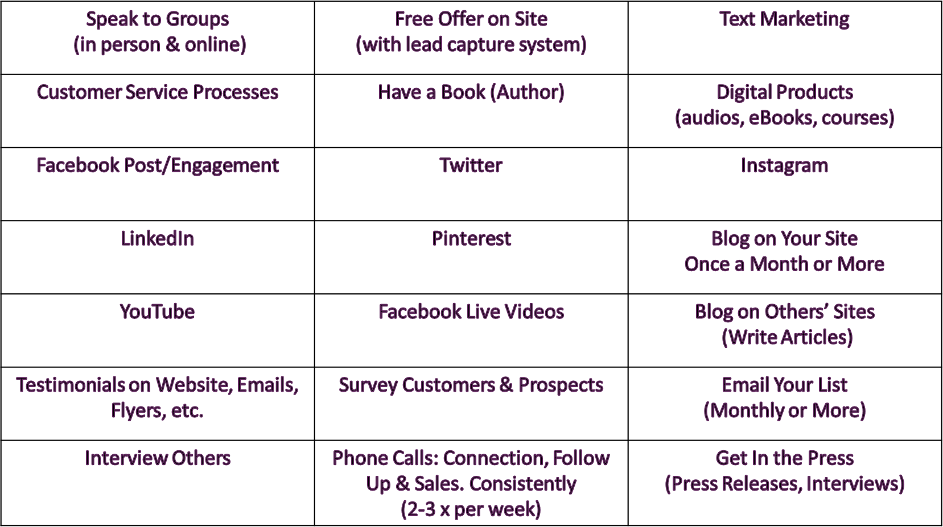
List the results you’re getting from the ✓ strategies:
- Growing your list (by how much) ______________________________
- New clients (how many, how often) ____________________________
- Strategic Alliances & Joint Venture Partners _____________________
- Resources for yourself or your business _______________________

After measuring and assessing the effectiveness of your current strategies, create your course for the remainder of the year. Which do you want to stop, start and/or continue?

Continue | Start | Stop

Create a 4-Week Marketing Plan

EXAMPLE
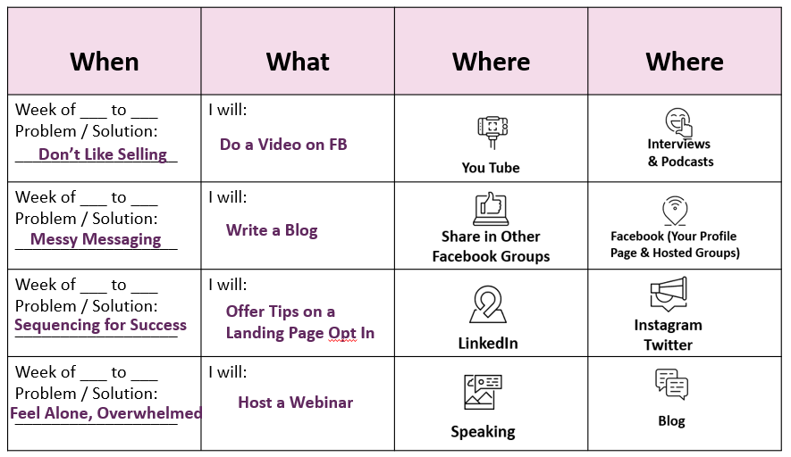

NOW YOU

From the problems / pain points you know your clients experience, choose one for each week … Voila! You now have a month’s worth of content ready to go.

